Dino Activity

Challenge!

1

© 2022 Little Owls Resources

© 2022 Little Owls Resources

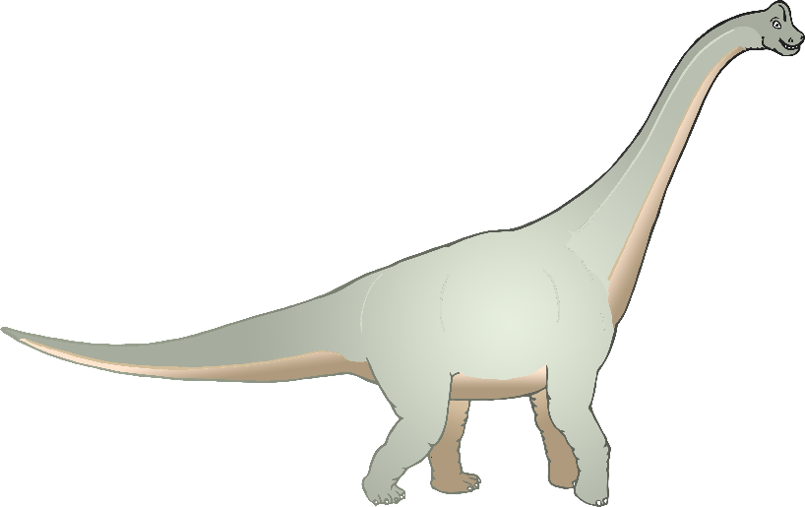

Stretch up tall like a brachiosaurus!

2

Dino Activity

Challenge!

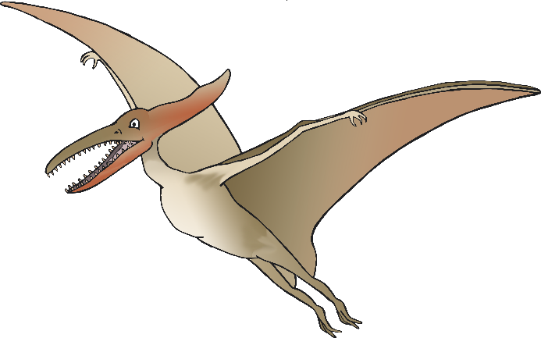

Flap your wings!

Swoop like a pterodactyl!

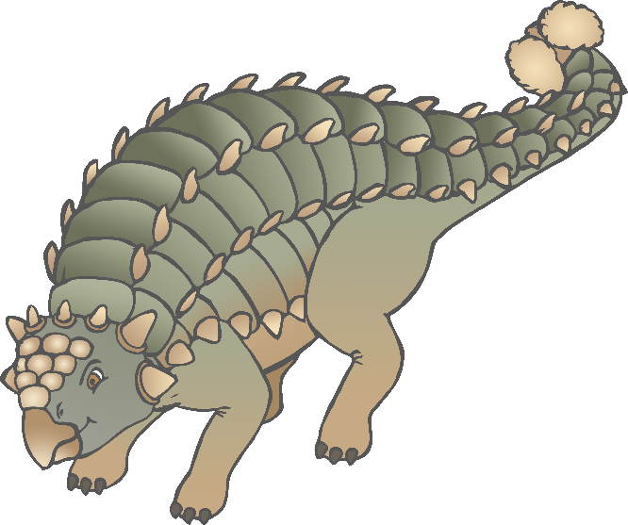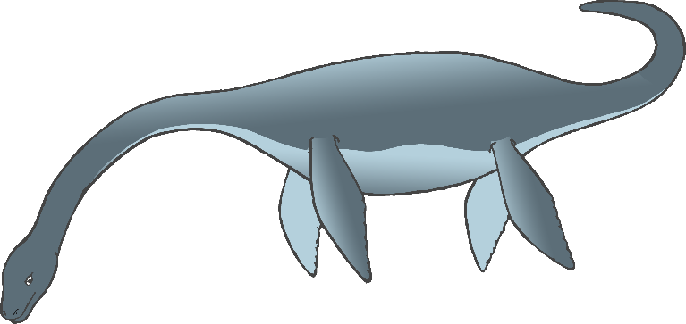

Dino Activity

Challenge!

3

© 2022 Little Owls Resources

© 2022 Little Owls Resources

Move slowly and heavily like an ankylosaurus!

4

Dino Activity

Challenge!

Swim through the sea like a plesiosaur… sway your long neck!

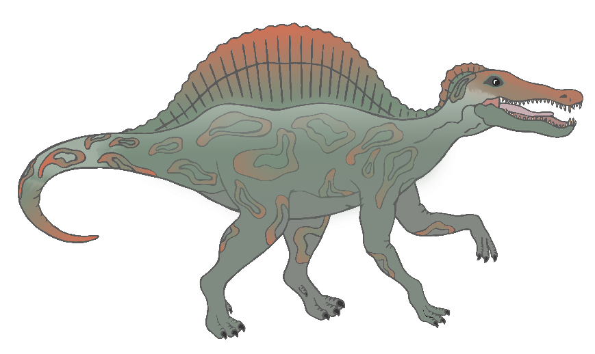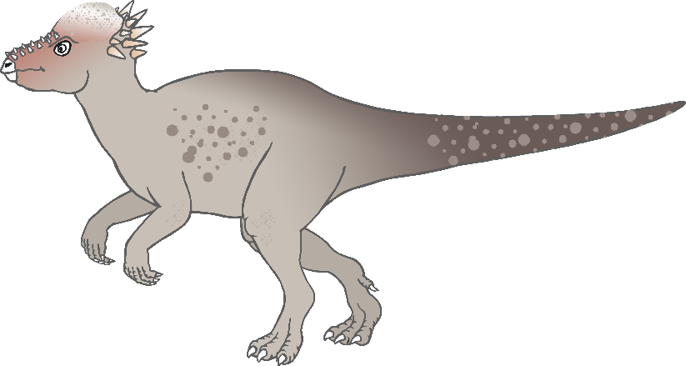

Snap your jaws like Spinosaurus and catch a fish.

Move quickly on your tiptoes like a pachycephalosaurus!

6

5

Dino Activity

Challenge!

© 2022 Little Owls Resources

© 2022 Little Owls Resources

Dino Activity

Challenge!

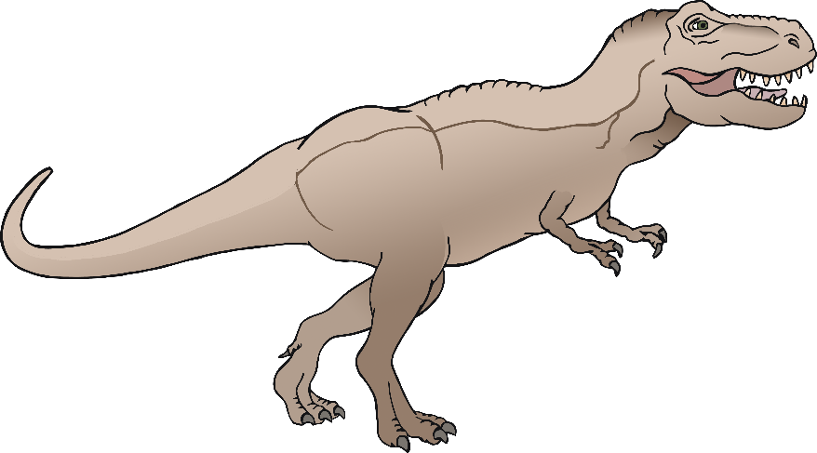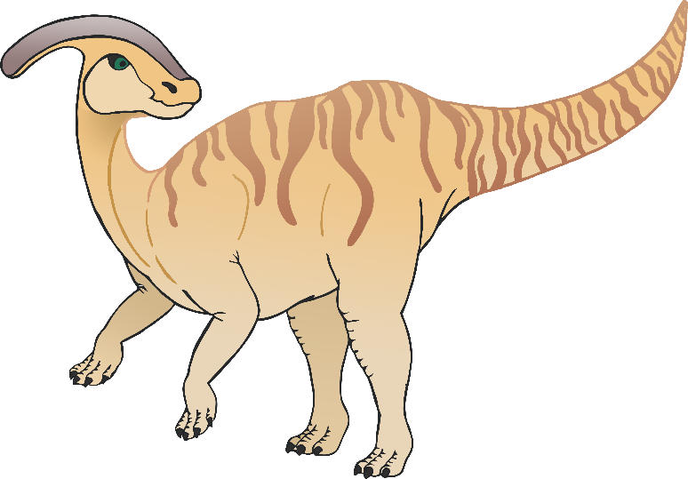

Stomp like a T-Rex!

**Stomp! Stomp!**

**ROAR!!**

Call out with your head crest like a parasaurolophus!

**Toot! Toot!**

8

7

Dino Activity

Challenge!

© 2022 Little Owls Resources

© 2022 Little Owls Resources

Dino Activity

Challenge!