**Brachiosaurus**

© 2022 Little Owls Resources

**Pachycephalosaurus**

© 2022 Little Owls Resources

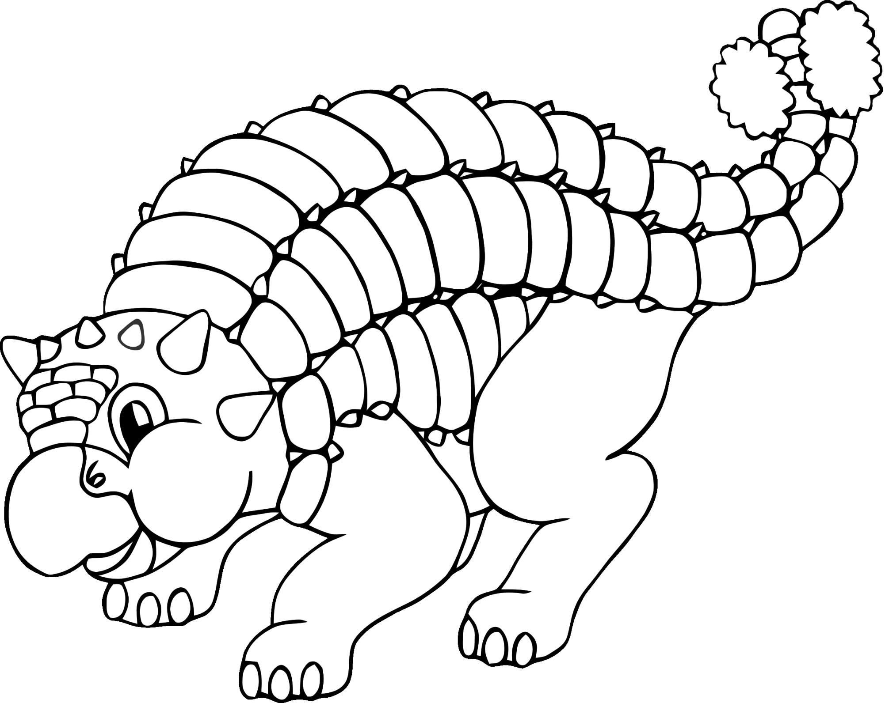

**Ankylosaurus**

© 2022 Little Owls Resources

**Parasaurolophus**

© 2022 Little Owls Resources

**Plesiosaurus**

© 2022 Little Owls Resources

**Pterodactyl**

© 2022 Little Owls Resources

**Stegosaurus**

© 2022 Little Owls Resources

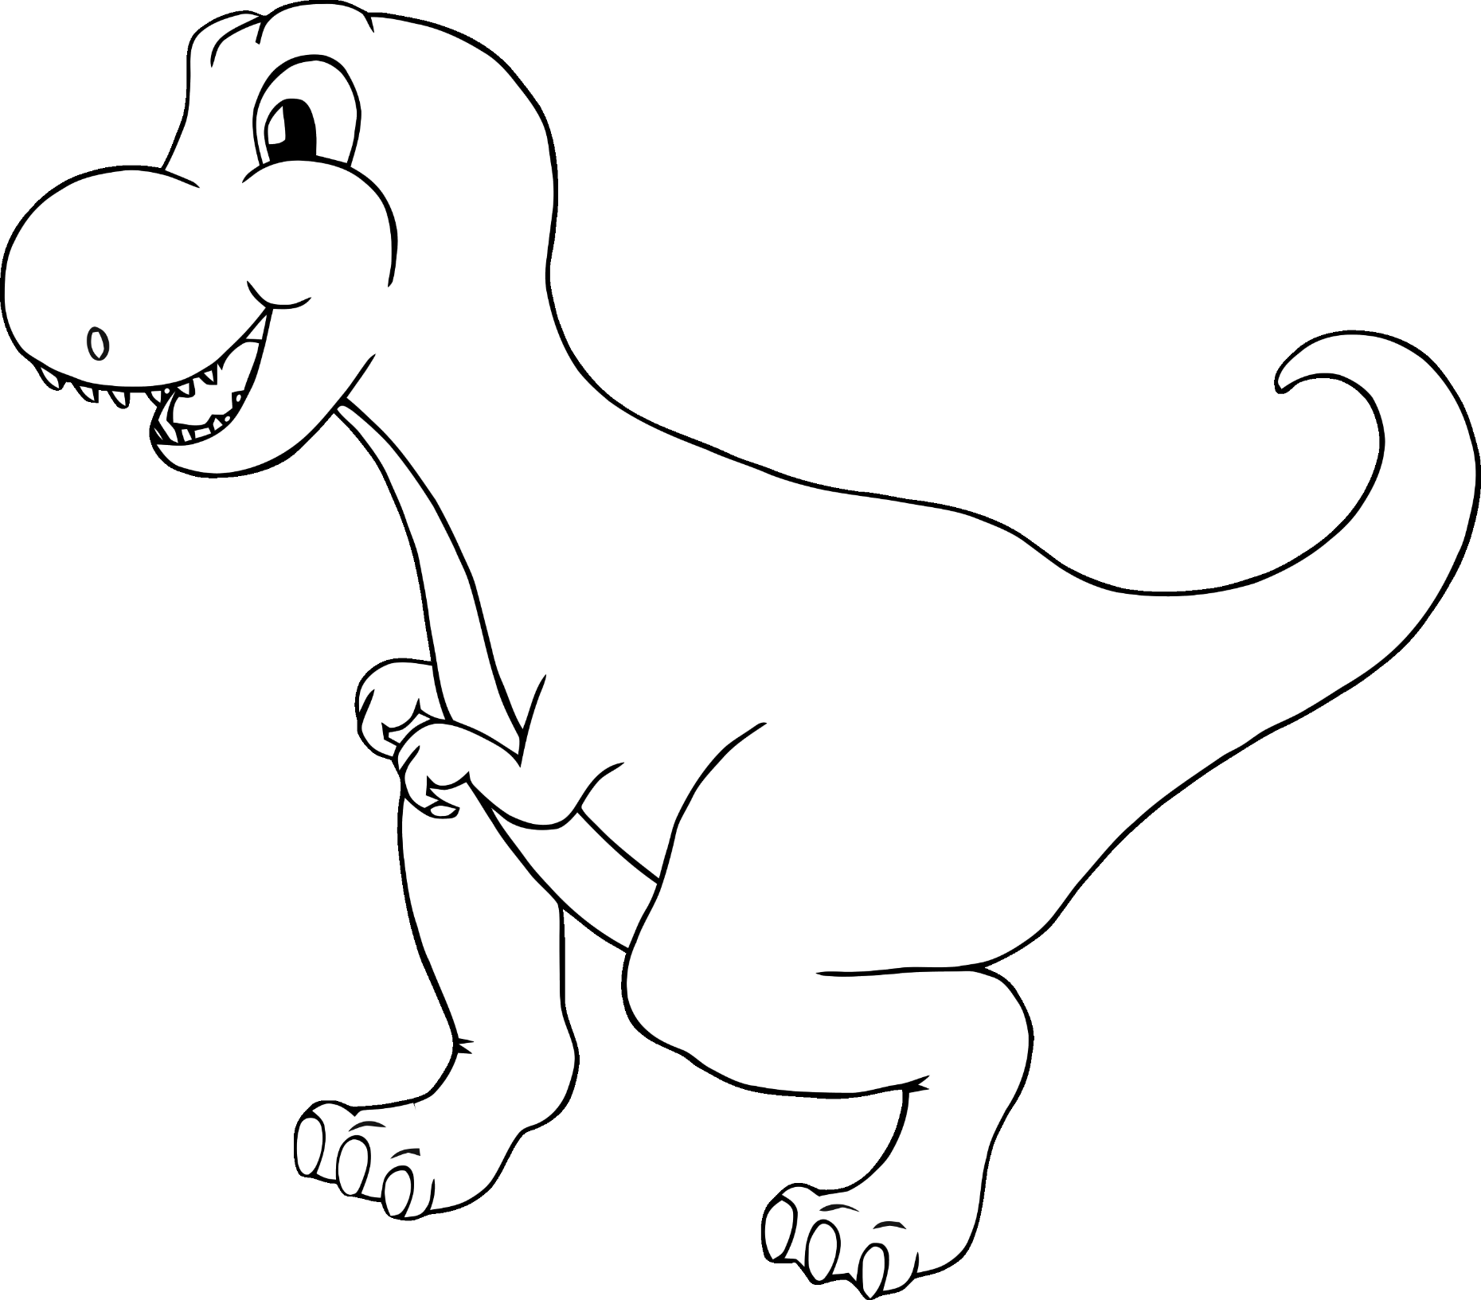

**Tyrannosaurus Rex**

© 2022 Little Owls Resources

**Triceratops**

© 2022 Little Owls Resources