**Dinosaur Silhouette Match**

© 2022 Little Owls Resources

Can you match the dinosaur picture to the silhouette?

Fold along the line, stick together and laminate.

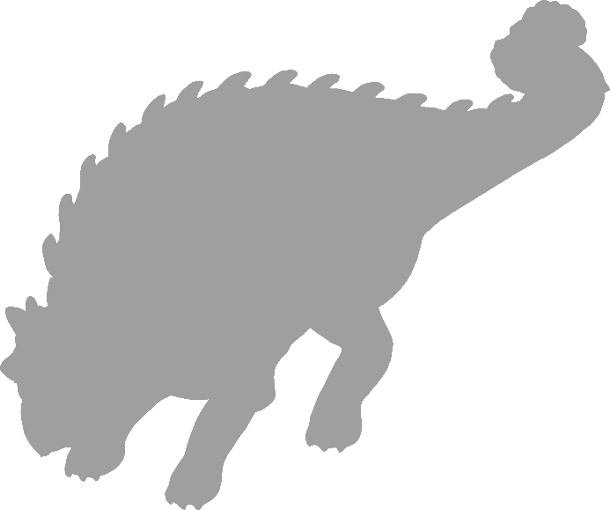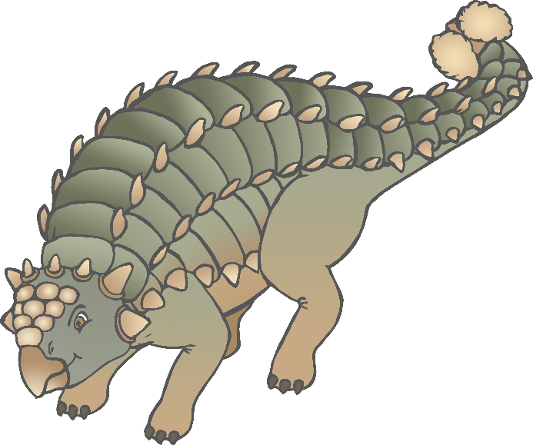

© 2019 Little Owls Resources

© 2019 Little Owls Resources

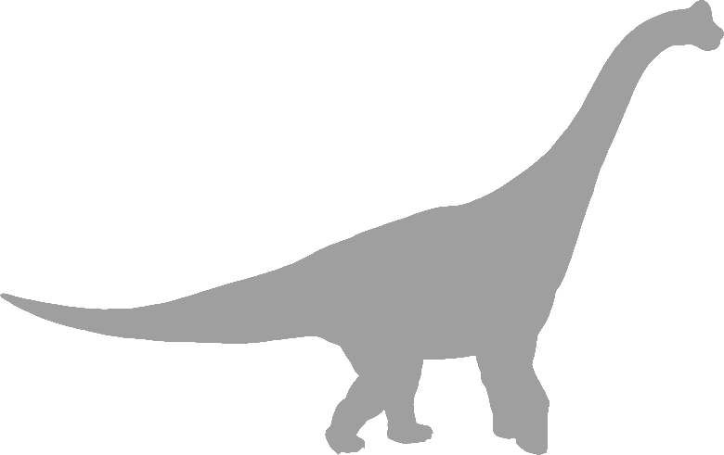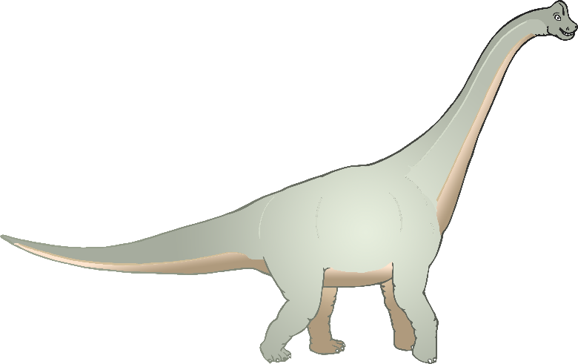

© 2019 Little Owls Resources

© 2019 Little Owls Resources

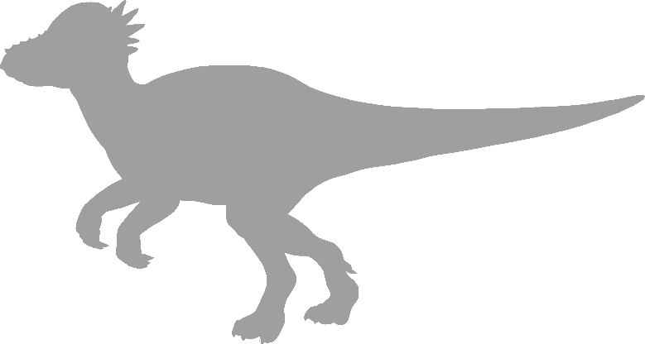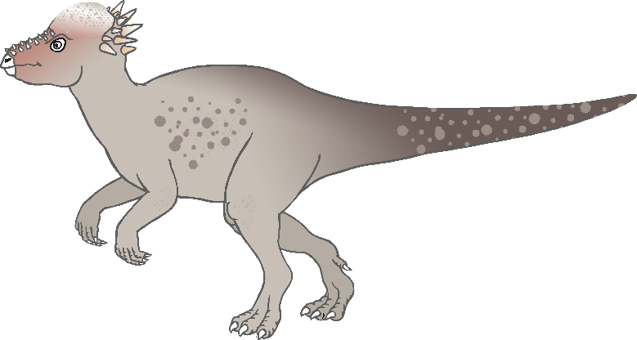

© 2019 Little Owls Resources

© 2019 Little Owls Resources

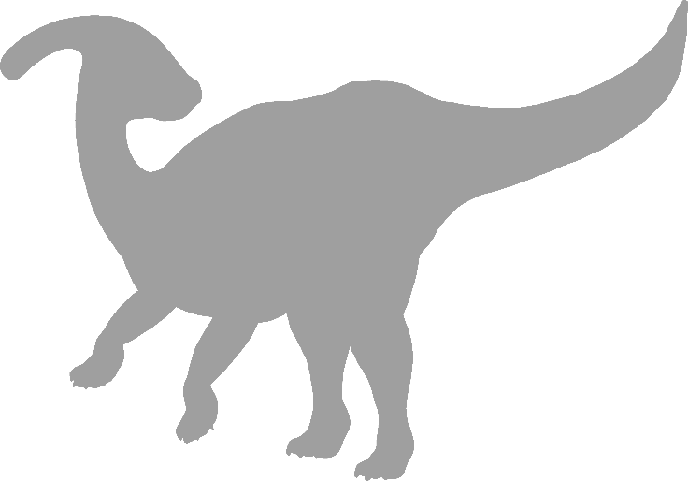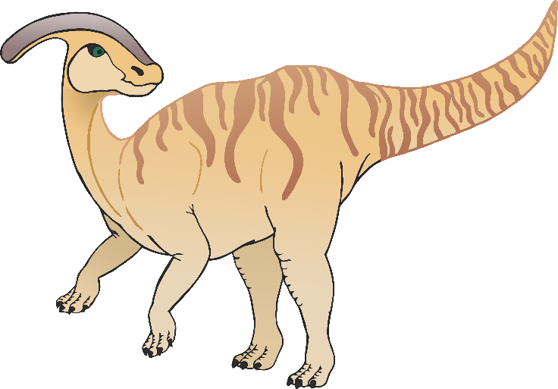

© 2019 Little Owls Resources

© 2019 Little Owls Resources

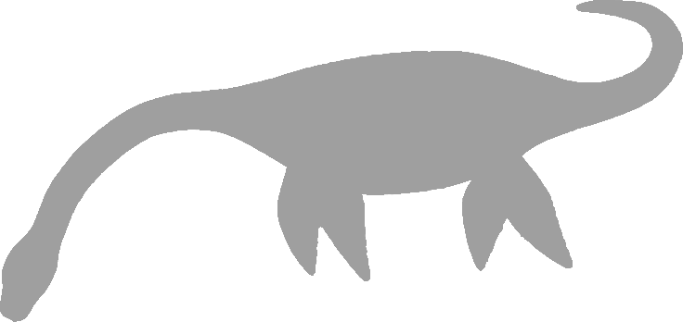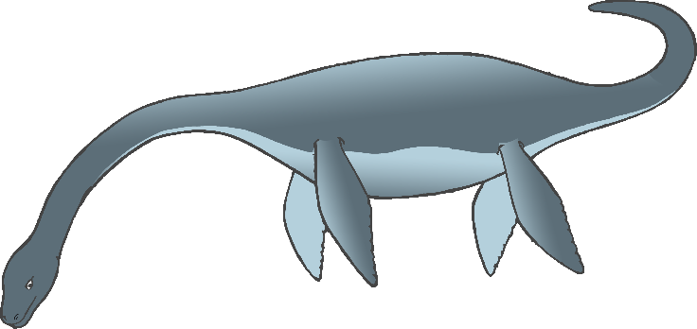

© 2019 Little Owls Resources

© 2019 Little Owls Resources

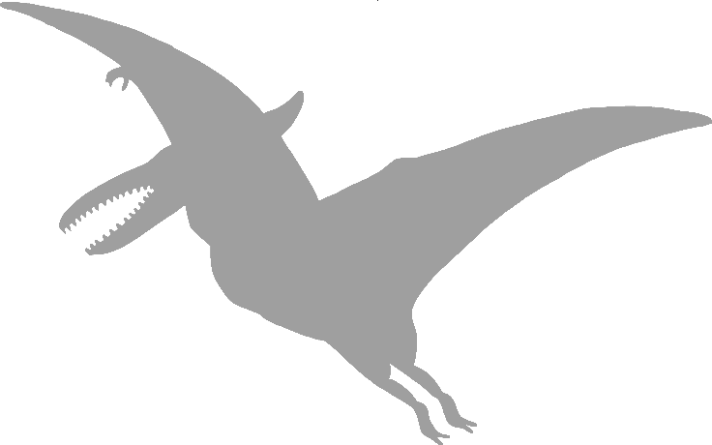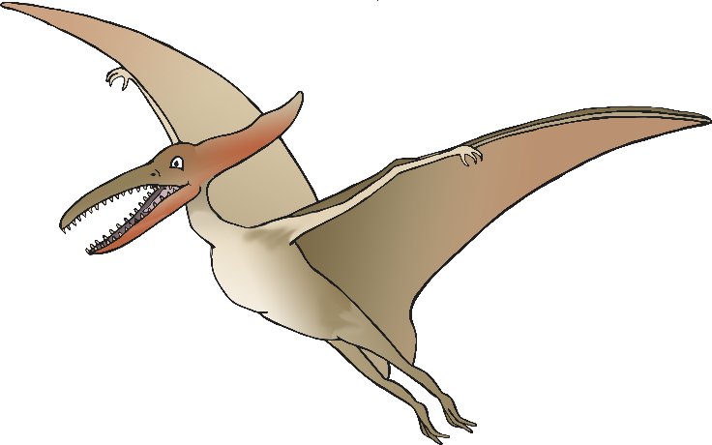

© 2019 Little Owls Resources

© 2019 Little Owls Resources

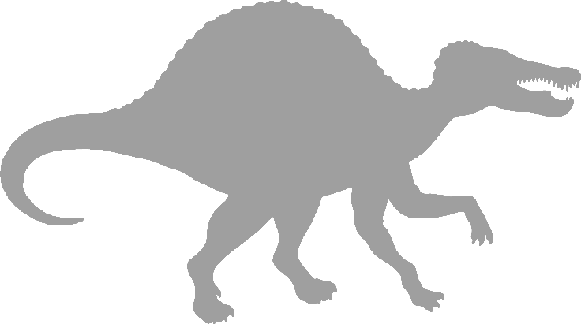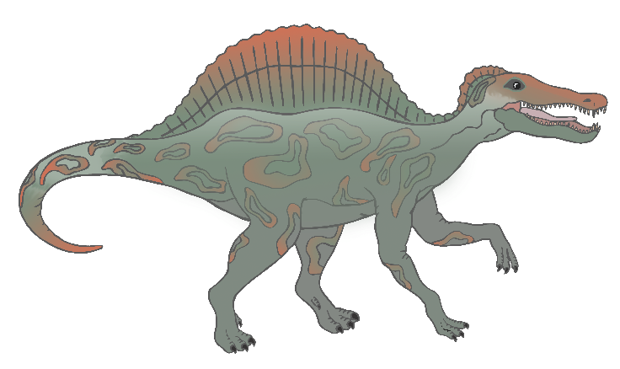

© 2019 Little Owls Resources

© 2019 Little Owls Resources

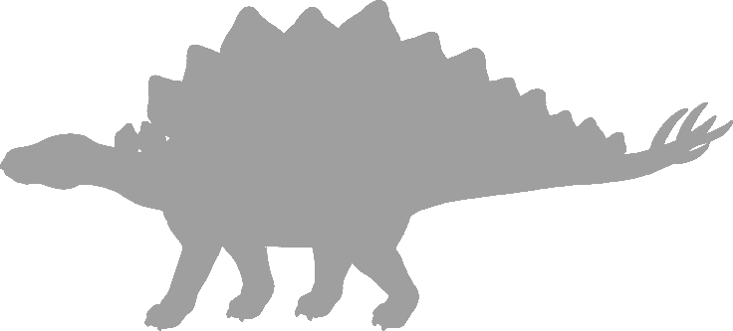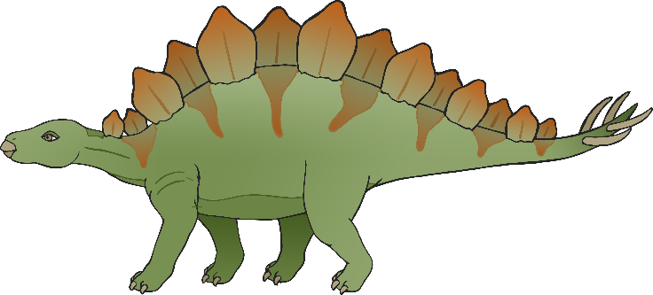

© 2019 Little Owls Resources

© 2019 Little Owls Resources

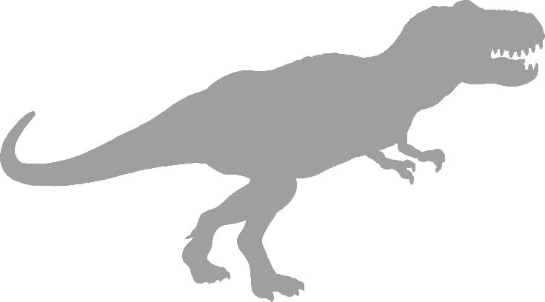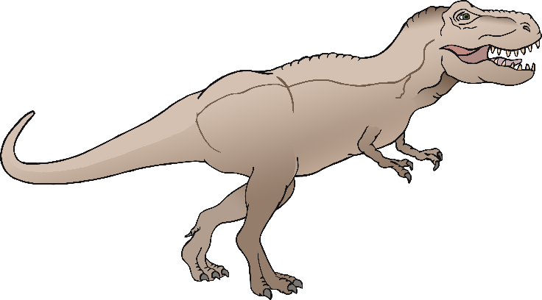

© 2019 Little Owls Resources

© 2019 Little Owls Resources

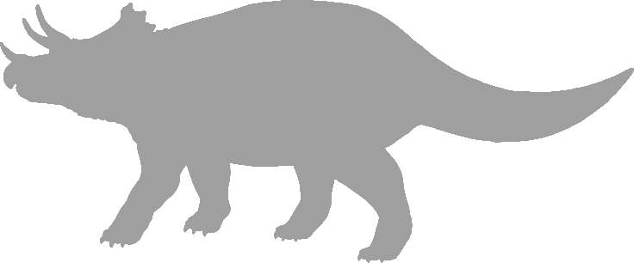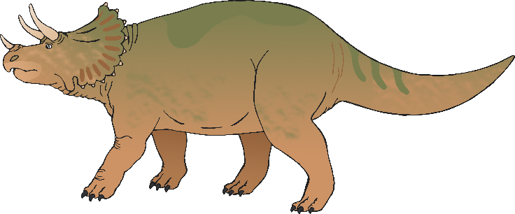

© 2019 Little Owls Resources

© 2019 Little Owls Resources