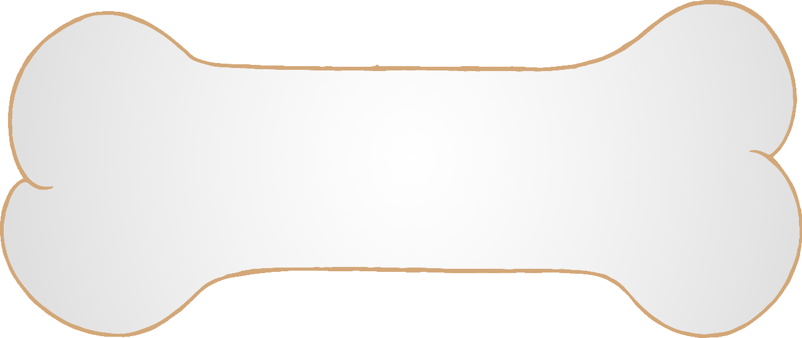

**w**ill

© 2019 Little Owls Resources

that

© 2019 Little Owls Resources

this

© 2019 Little Owls Resources

then

© 2019 Little Owls Resources



them

© 2019 Little Owls Resources

**w**ith

© 2019 Little Owls Resources

see

© 2019 Little Owls Resources

for

© 2019 Little Owls Resources



no**w**

© 2019 Little Owls Resources

do**w**n

© 2019 Little Owls Resources

look

© 2019 Little Owls Resources

too

© 2019 Little Owls Resources



he

© 2019 Little Owls Resources

she

© 2019 Little Owls Resources

**w**e

© 2019 Little Owls Resources

me

© 2019 Little Owls Resources



be

© 2019 Little Owls Resources

**w**as

© 2019 Little Owls Resources

you

© 2019 Little Owls Resources

they

© 2019 Little Owls Resources



all

© 2019 Little Owls Resources

are

© 2019 Little Owls Resources

my

© 2019 Little Owls Resources

her

© 2019 Little Owls Resources