Dig holes!



© 2023 Little Owls Resources

**Digging Area Challenge!**

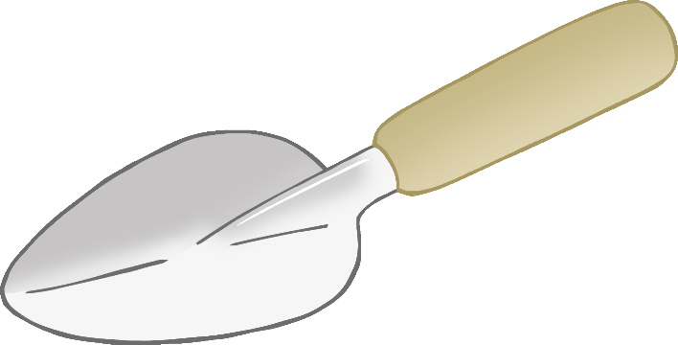

**2**

Dig holes!



© 2023 Little Owls Resources

**Digging Area Challenge!**



**3**

Dig holes!



© 2023 Little Owls Resources

**Digging Area Challenge!**



**4**

Dig holes!



© 2023 Little Owls Resources

**Digging Area Challenge!**



**5**

Dig holes!



© 2023 Little Owls Resources

**Digging Area Challenge!**



**6**

Dig holes!



© 2023 Little Owls Resources

**Digging Area Challenge!**



**7**

Dig holes!



© 2023 Little Owls Resources

**Digging Area Challenge!**



**8**

Dig holes!



© 2023 Little Owls Resources

**Digging Area Challenge!**



**9**

Dig holes!



© 2023 Little Owls Resources

**Digging Area Challenge!**



**10**