Can you draw a head for this flamingo?

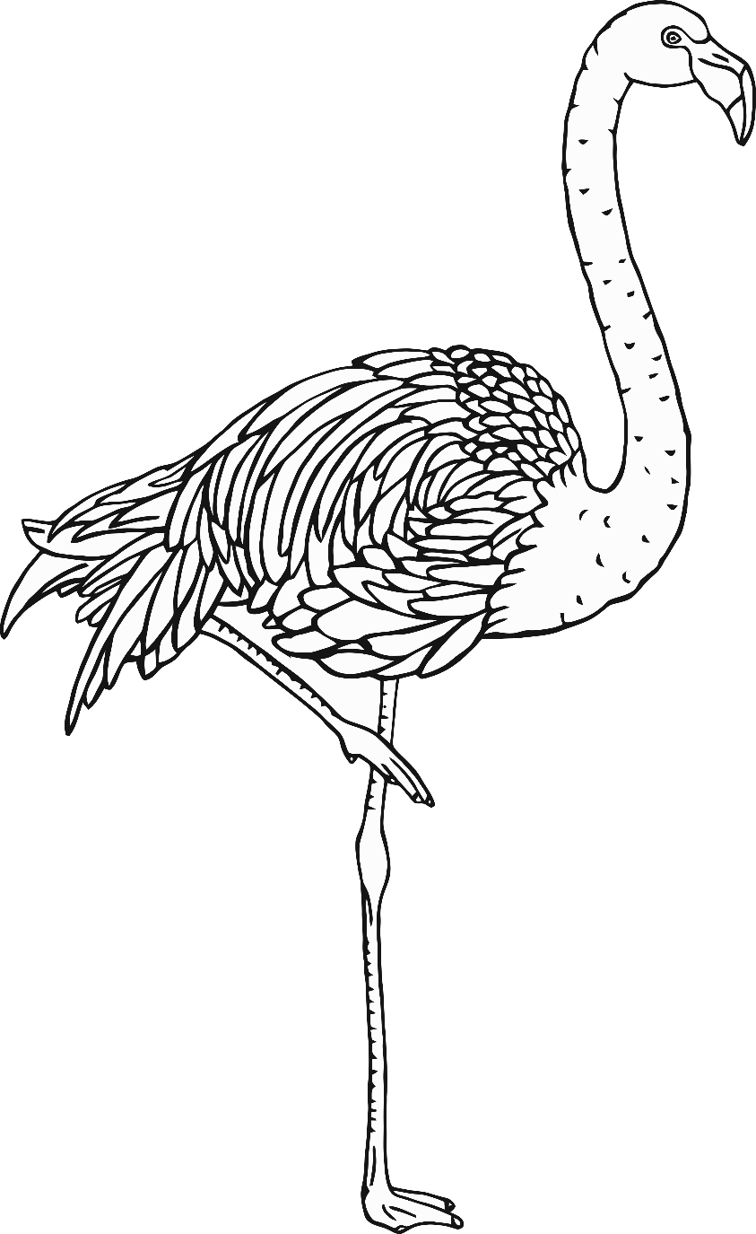

Can you draw a tail for this giraffe?

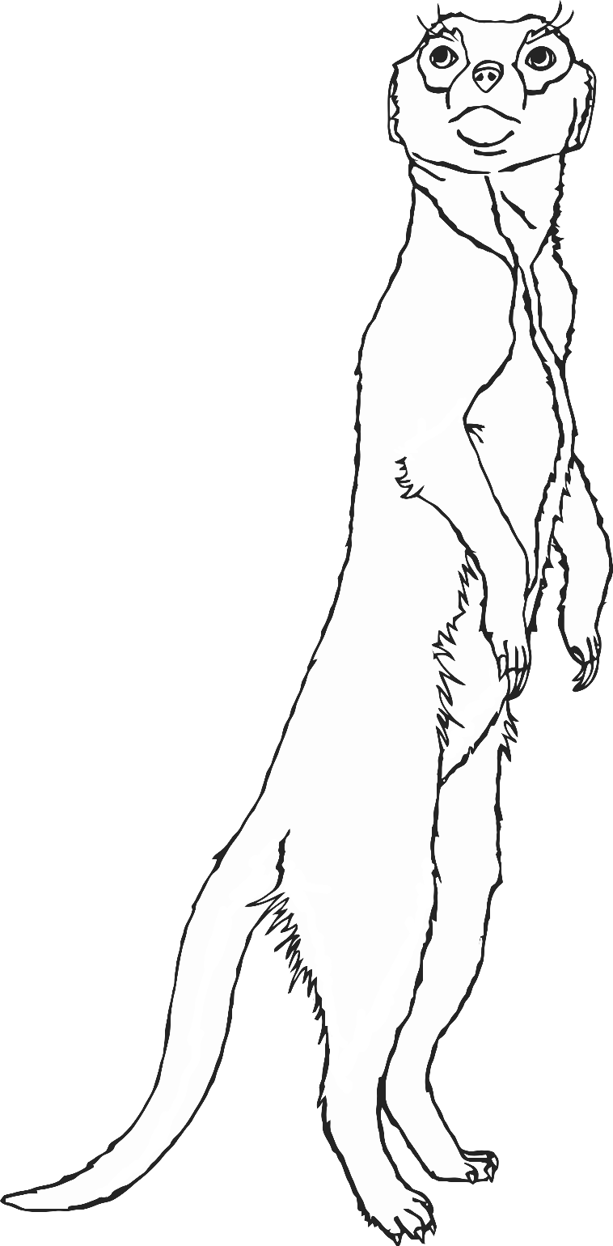

Can you draw legs for this meerkat?

Can you draw a head for this wolf?

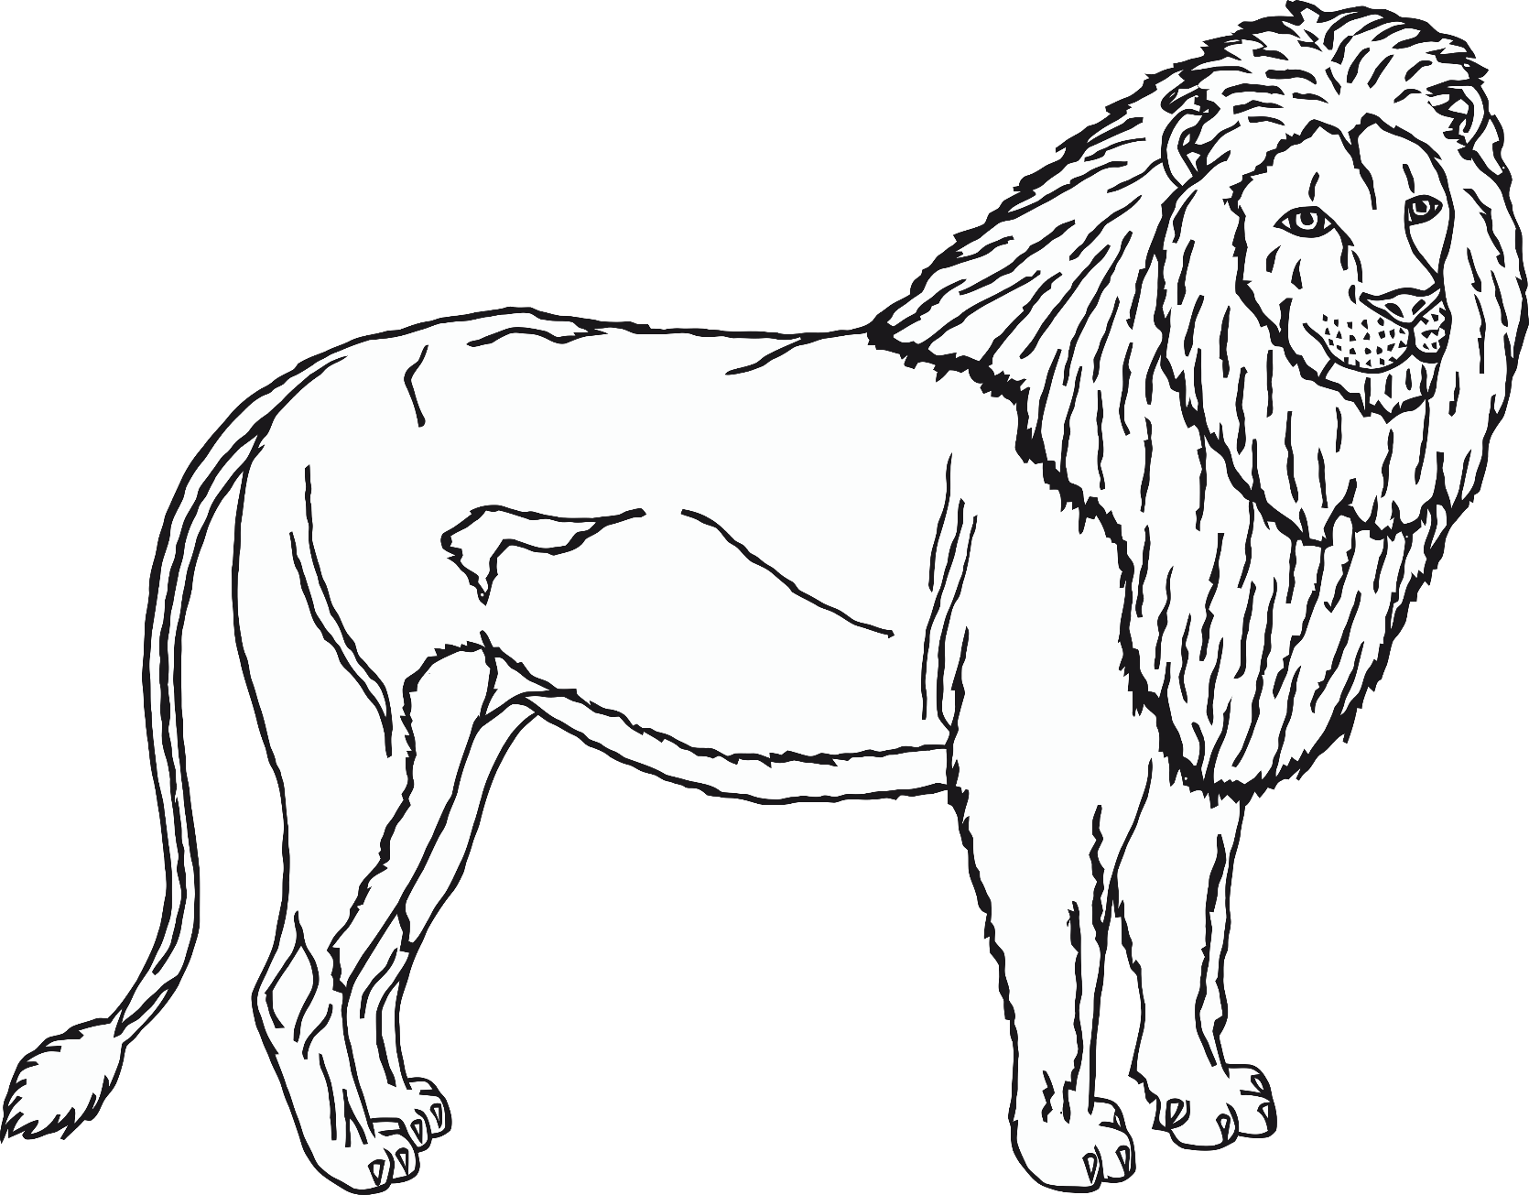

Can you draw a tail for this lion?

Can you draw legs for this zebra?

Design your own zoo animal!