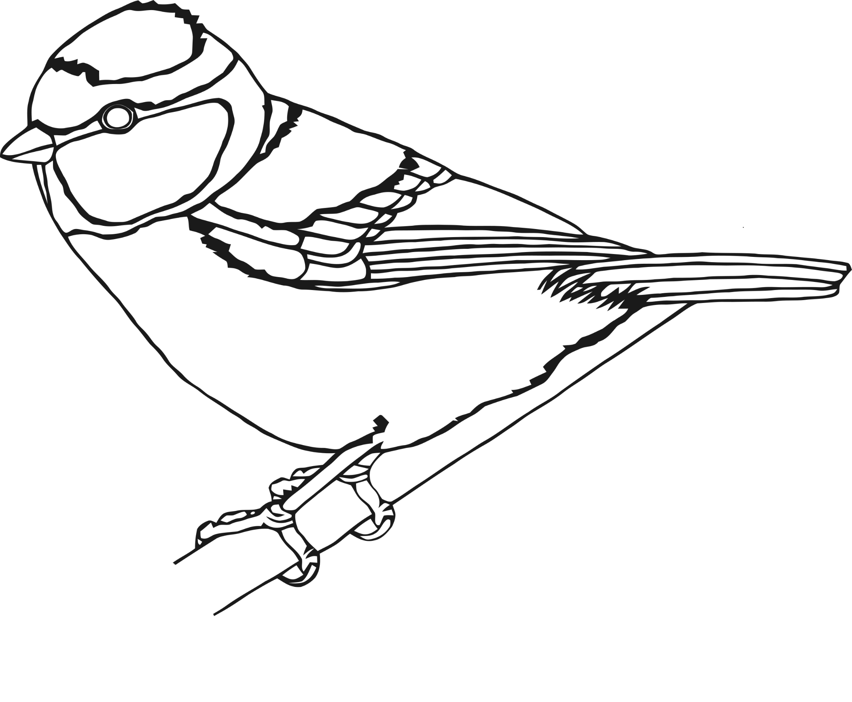

Can you draw a head for this garden bird?

Can you draw legs for this garden bird?

Can you draw a head for this garden bird?

Can you draw a tail for this garden bird?

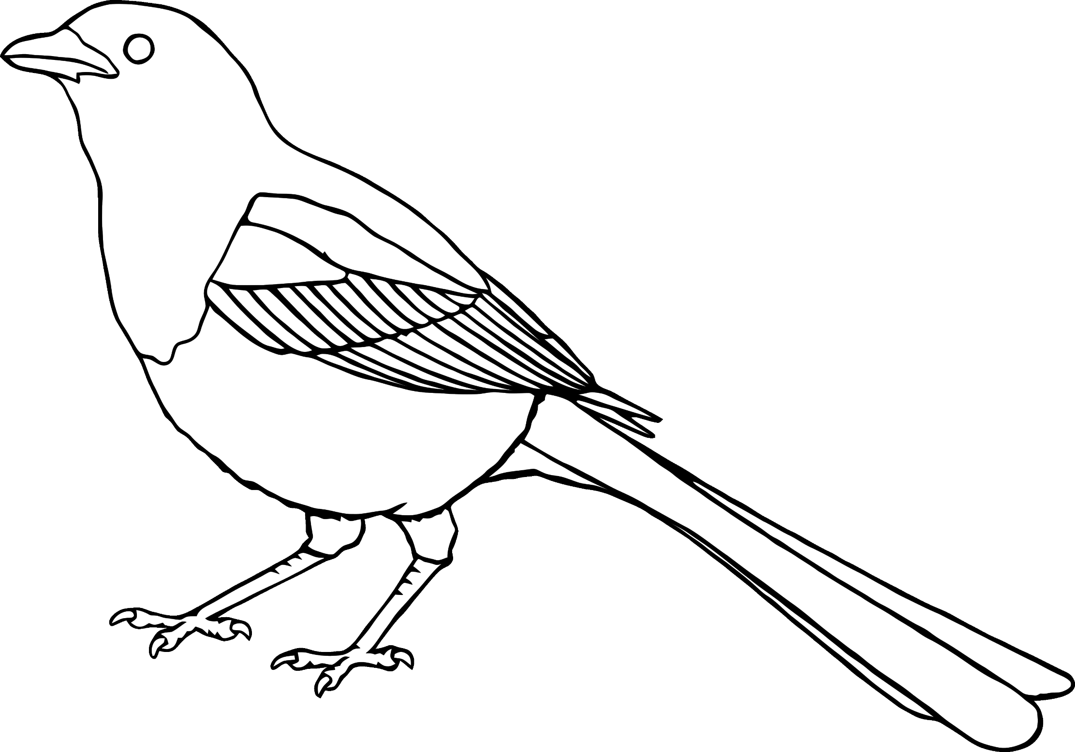

Can you draw legs for this garden bird?

Design your own garden bird!