© 2022 Little Owls Resources

Can you draw a head for this dinosaur?

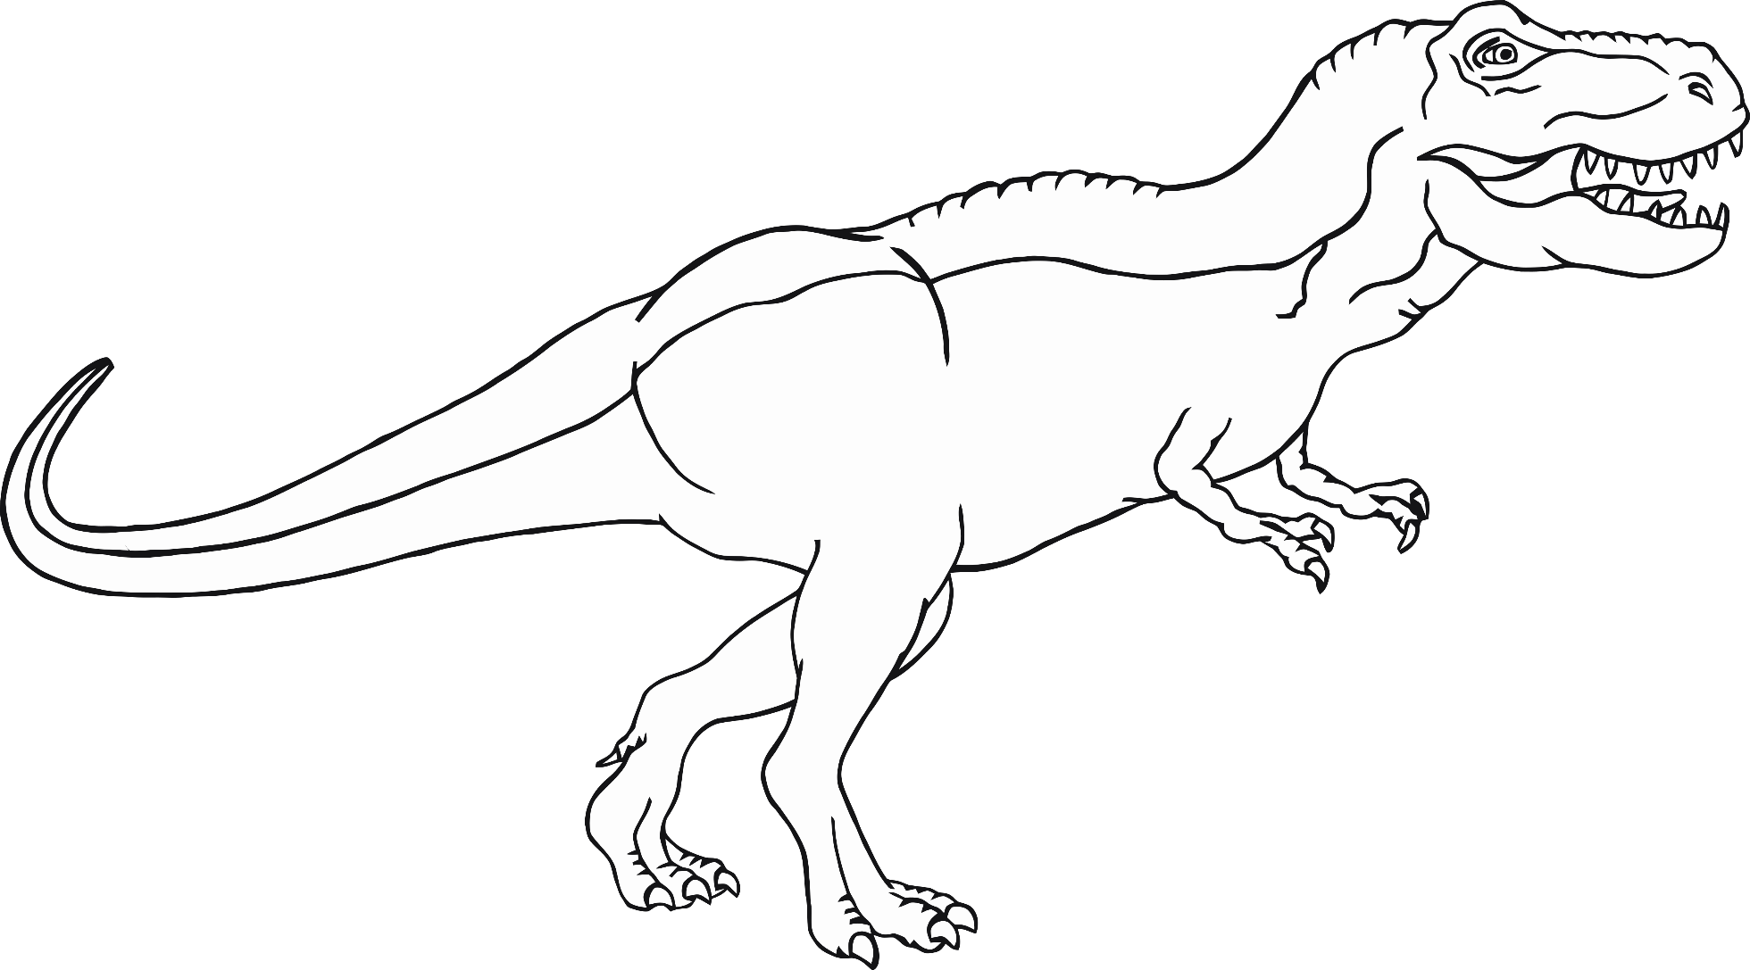

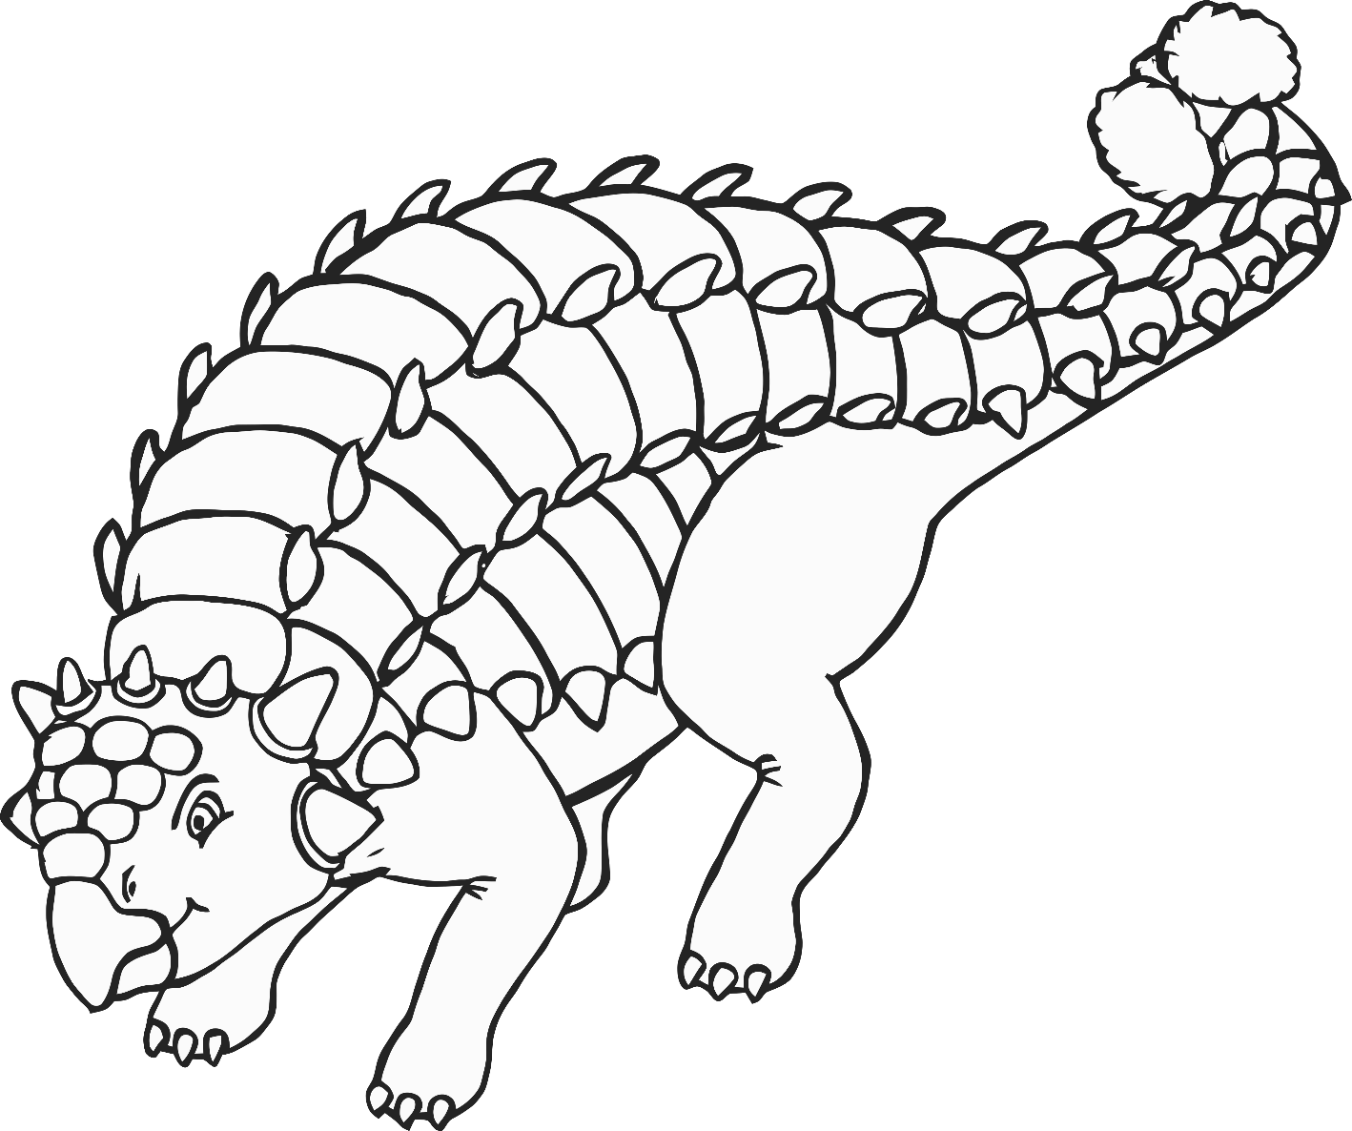

Can you draw a tail for this dinosaur?

© 2022 Little Owls Resources

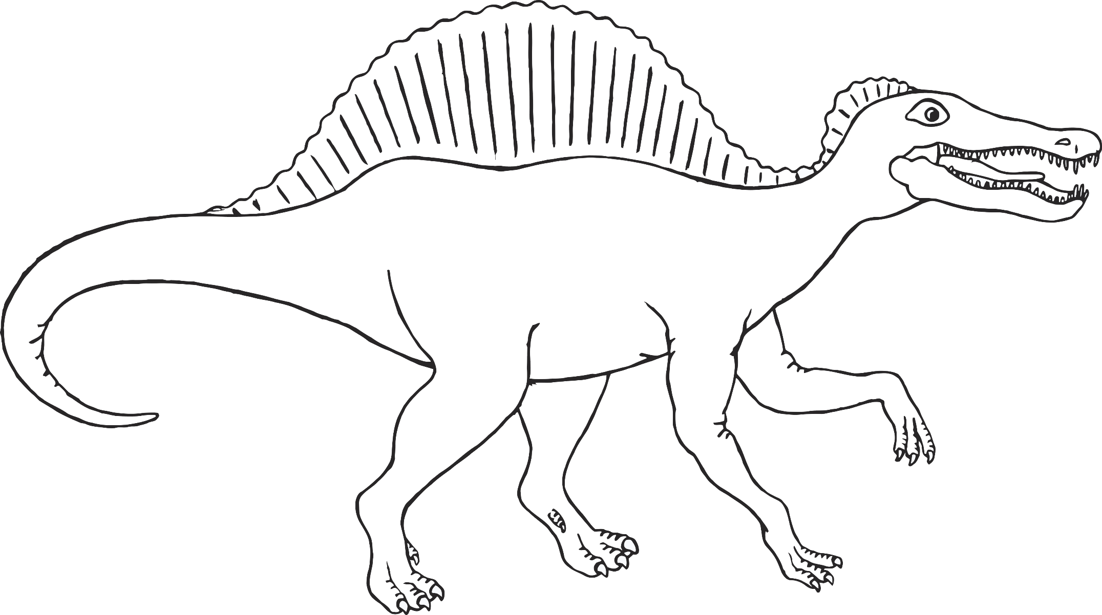

Can you draw legs for this dinosaur?

© 2022 Little Owls Resources

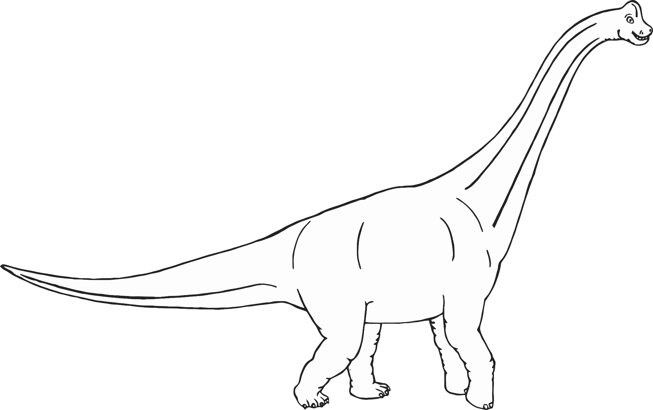

Can you draw a head for this dinosaur?

© 2022 Little Owls Resources

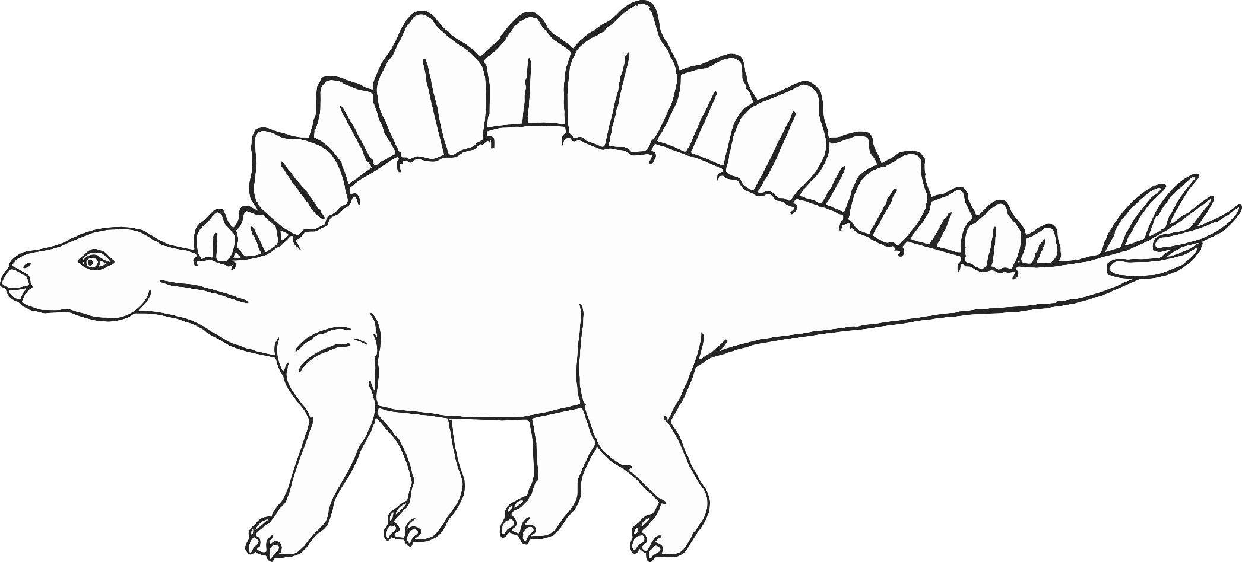

Can you draw a tail for this dinosaur?

© 2022 Little Owls Resources

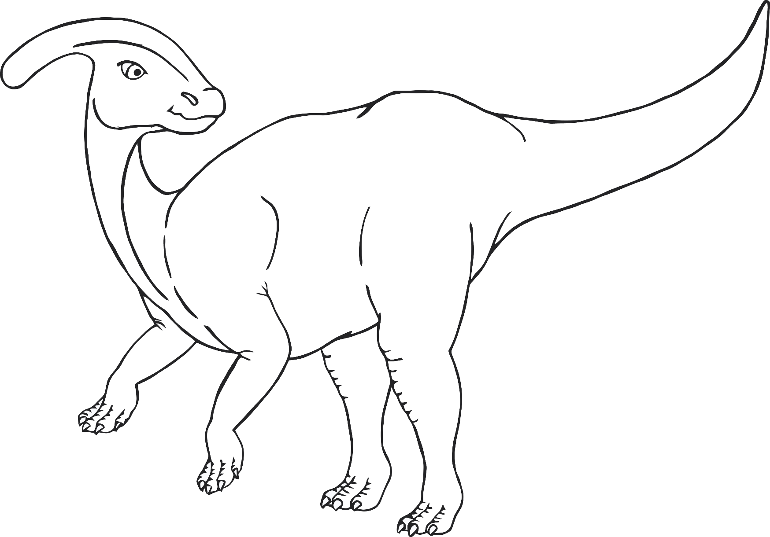

Can you draw legs for this dinosaur?

© 2022 Little Owls Resources

Design your own dinosaur!