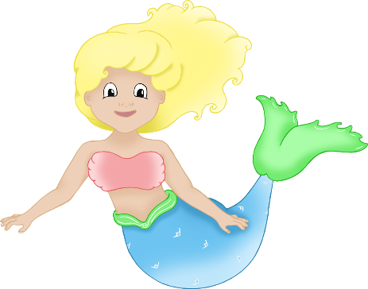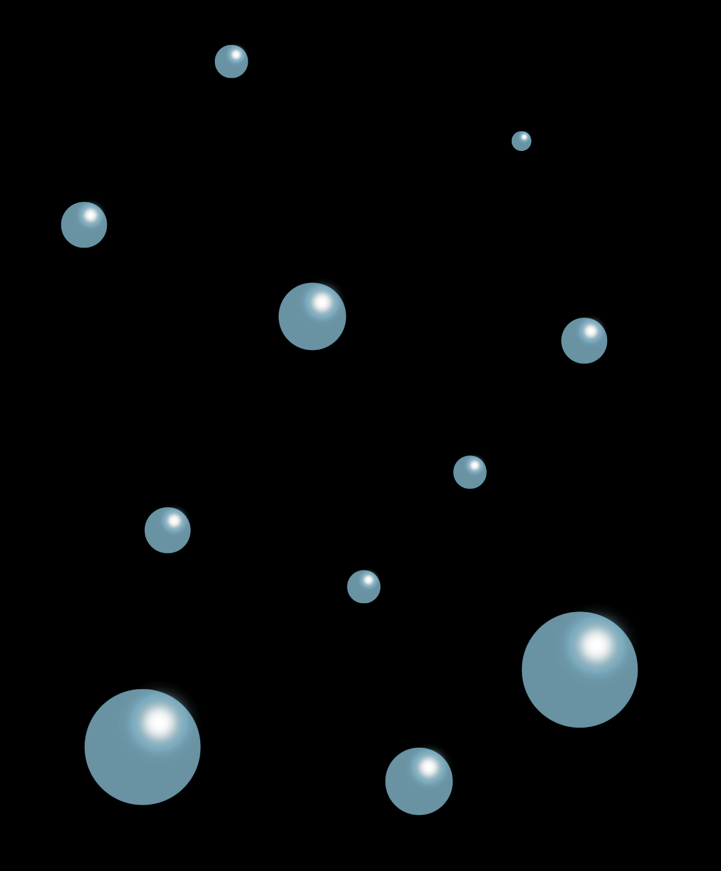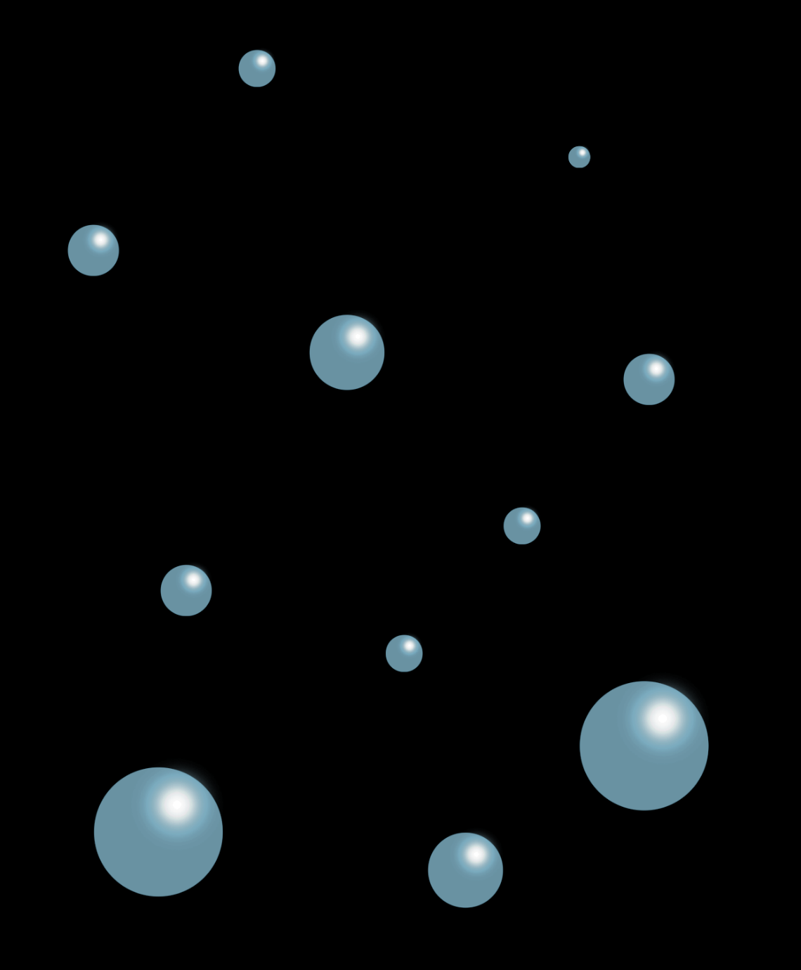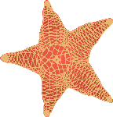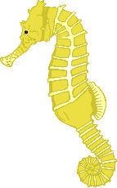

**Design a Mermaid!**

© 2023 Little Owls Resources

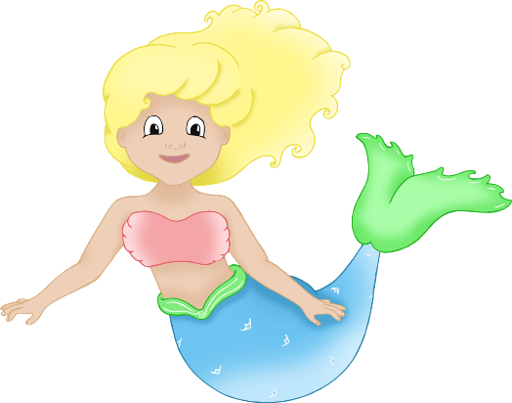

**Design a Mermaid!**

© 2023 Little Owls Resources

Mermaid name:



**Design a Mermaid!**

Mermaid name:

What is their special power?

Where is their home?

© 2023 Little Owls Resources



**Design a Mermaid!**

Where is their home?

What do they do for fun?

Mermaid name:

© 2023 Little Owls Resources

What is their special power?

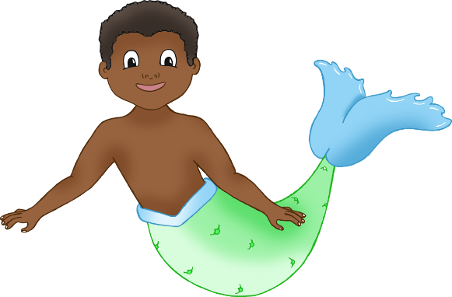

**Design a Merman!**

© 2023 Little Owls Resources



**Design a Merman!**

© 2023 Little Owls Resources

Merman name:



**Design a Merman!**

Merman name:

What is their special power?

Where is their home?

© 2023 Little Owls Resources



**Design a Merman!**

Where is their home?

What do they do for fun?

Merman name:

© 2023 Little Owls Resources

What is their special power?