**Design a Kilt**

© 2020 Little Owls Resources

**Design a Kilt**

© 2020 Little Owls Resources

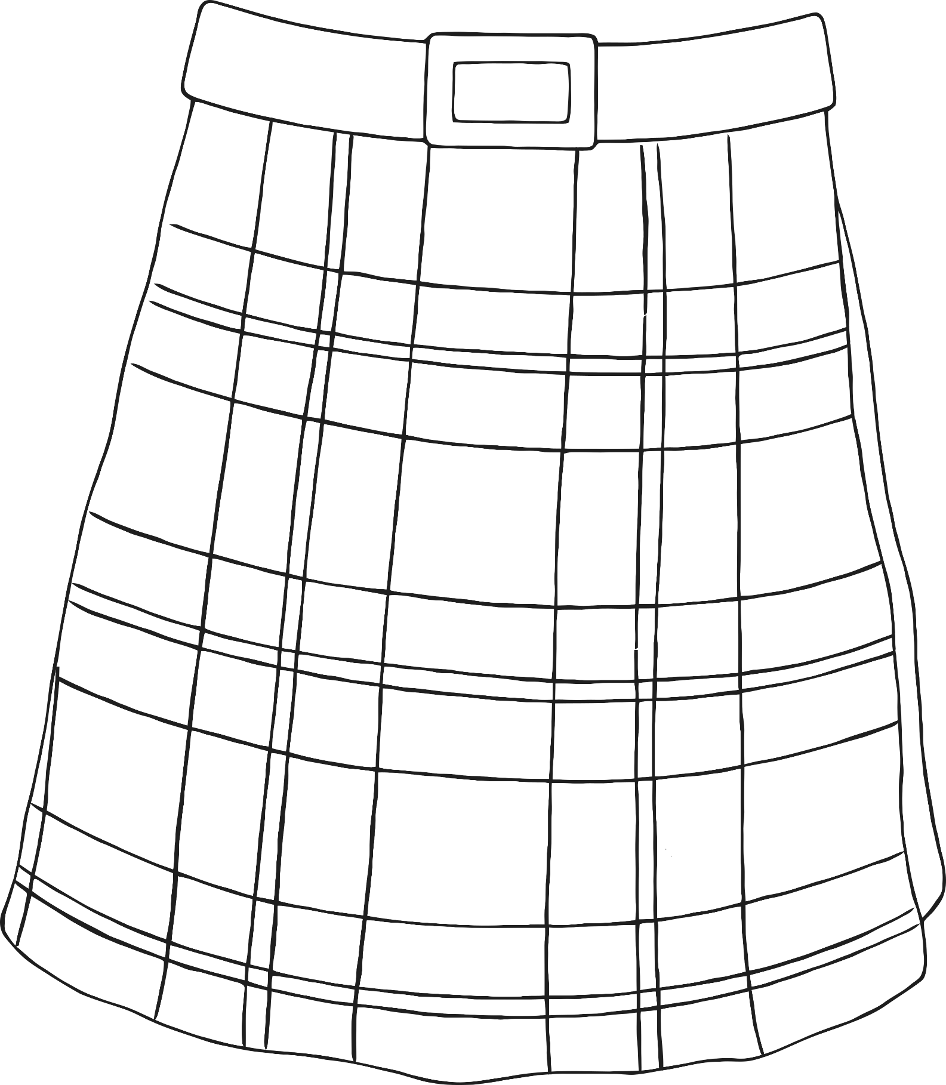

**Design a Kilt**

© 2020 Little Owls Resources

**Design a Kilt**

© 2020 Little Owls Resources

