Design a Fairy!

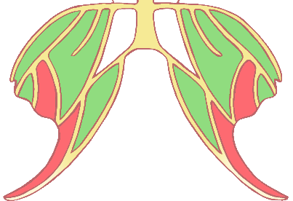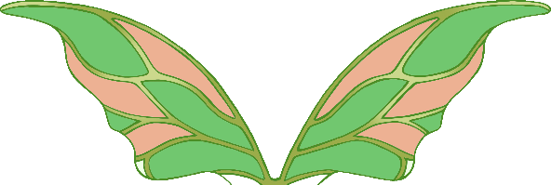

© 2021 Little Owls Resources

Design a Fairy!



© 2021 Little Owls Resources

Fairy name:

Design a Fairy!



Fairy name:

What is their magical power?

Where is their home?

© 2021 Little Owls Resources

Design a Fairy!



Where is their home?

What do they do for fun?

Name:

© 2021 Little Owls Resources

What is their magical power?