Instead of plastic bags…

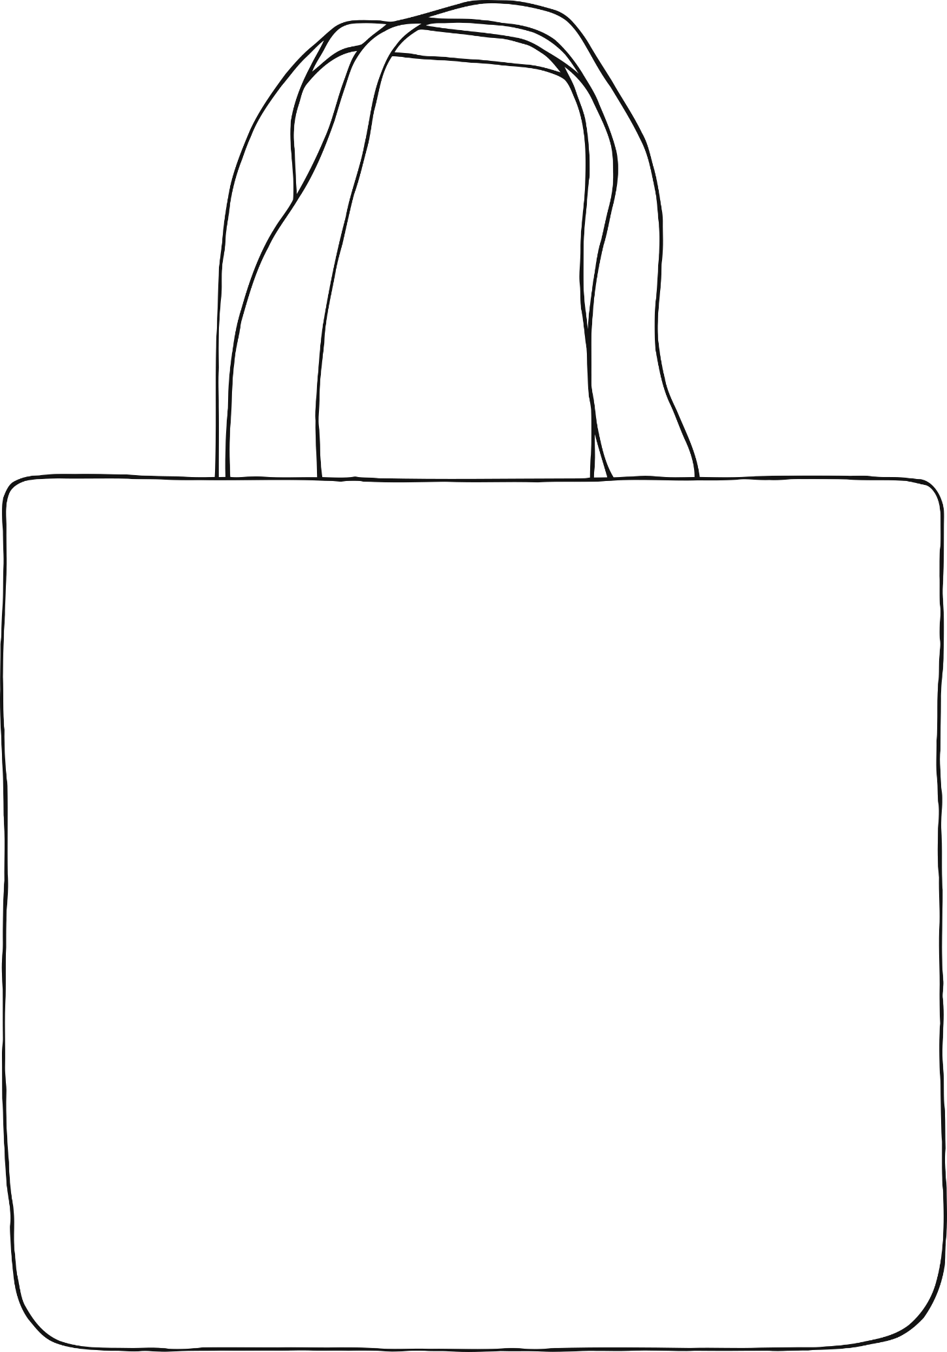

© 2021 Little Owls Resources

…design a bag for life!