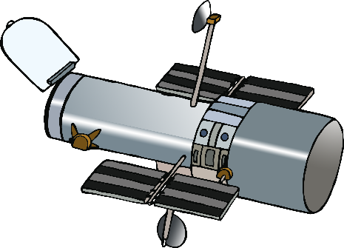

**WOW!**

What does it look like?

You found a new planet!