© 2022 Little Owls Resources

My emblem design…

Name:

The official emblem for the Platinum Jubilee was designed by nineteen-year-old Edward Roberts, a graphic design student from Nottinghamshire studying at Leeds University.

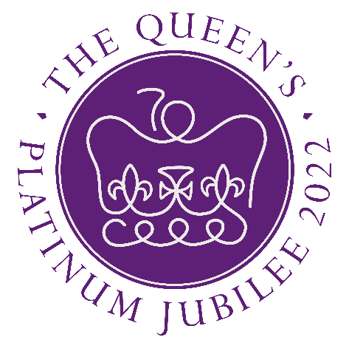

© 2022 Little Owls Resources

My emblem design…

Name:

The official emblem for the Platinum Jubilee was designed by nineteen-year-old Edward Roberts, a graphic design student from Nottinghamshire studying at Leeds University.

