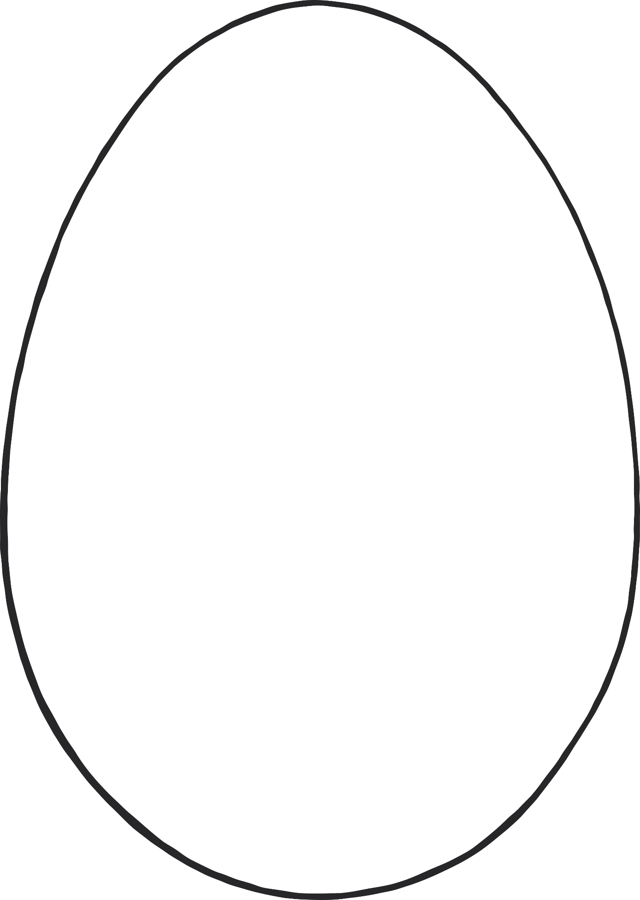

© 2022 Little Owls Resources

**Create your own egg design!**