**Design your own dinosaur egg!**

© 2022 Little Owls Resources

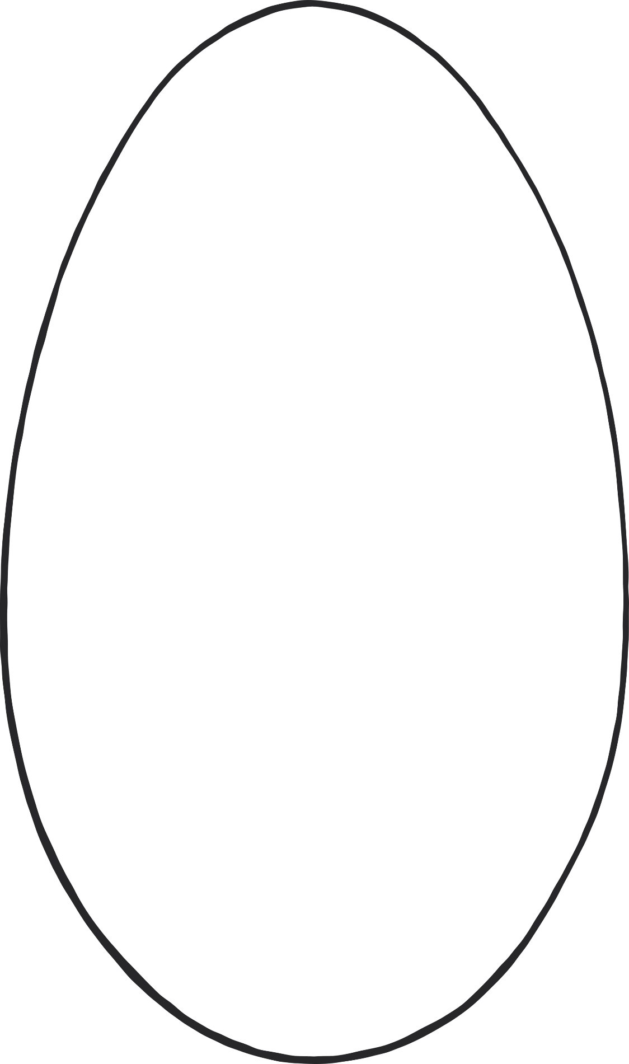

© 2022 Little Owls Resources

**Design your own**

**dinosaur egg!**