v

**Design your own…**

**Crown**

© 2022 Little Owls Resources

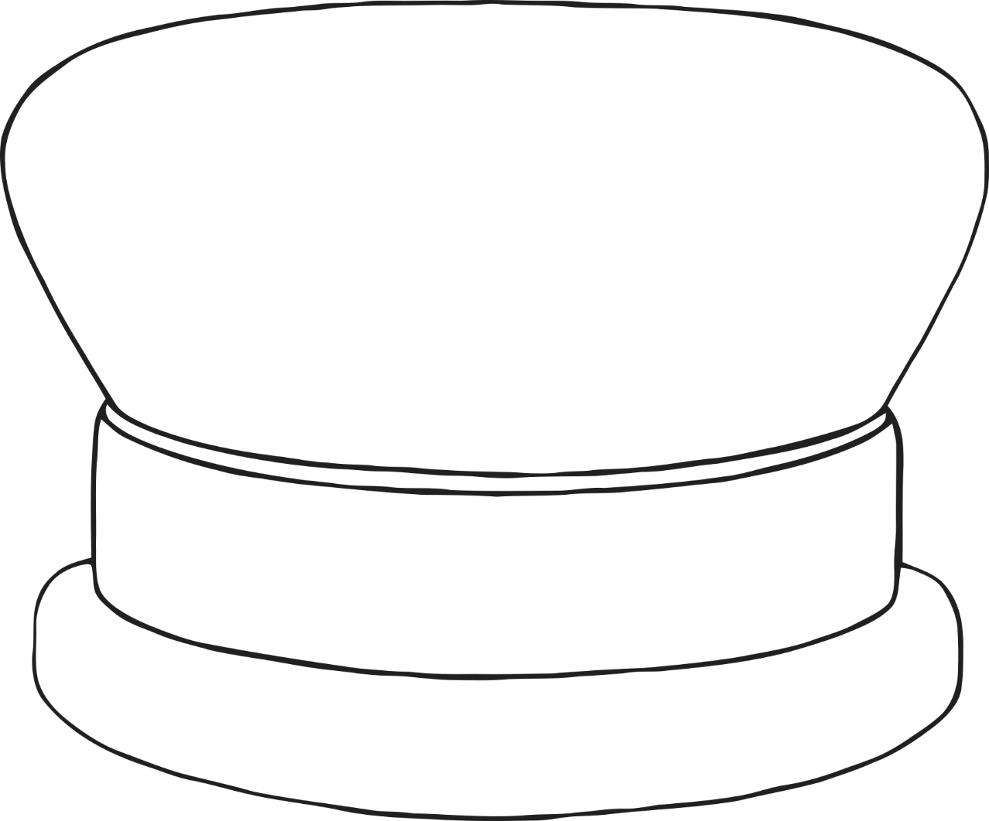

v

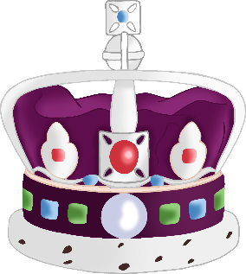

v

**Design your own…**

**Crown**

© 2022 Little Owls Resources

v

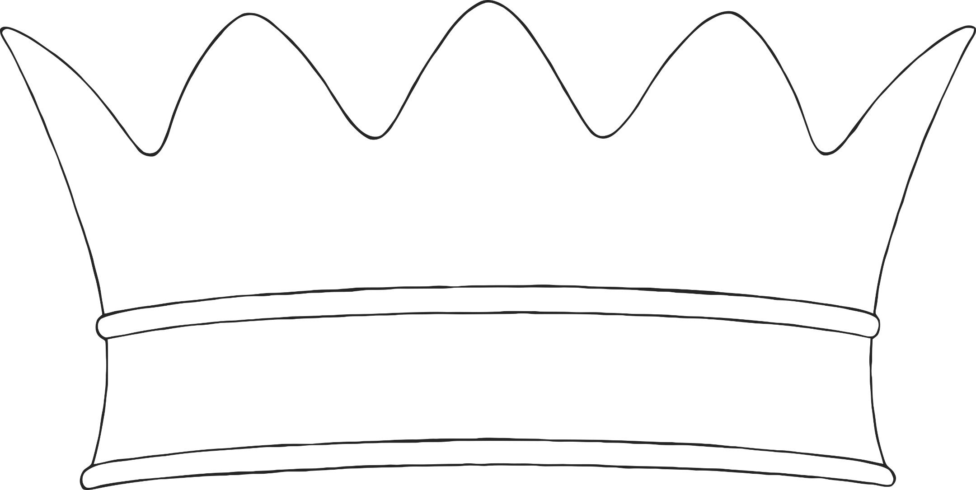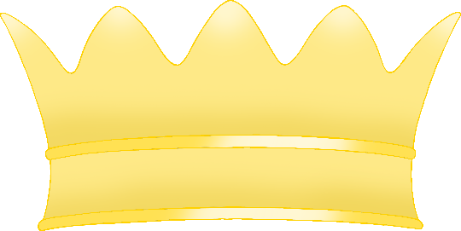

v

**Design your own…**

**Crown**

© 2022 Little Owls Resources



v

v

**Design your own…**

**Crown**

© 2022 Little Owls Resources

v