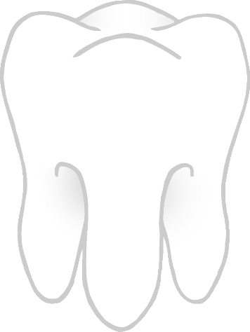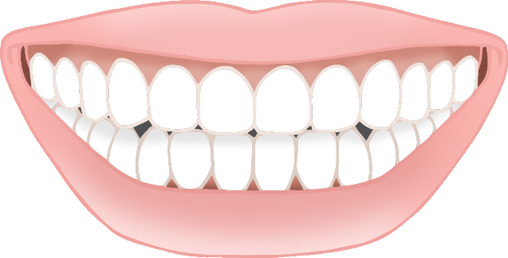

Tooth

Teeth

Toothbrush

© 2021 Little Owls Resources

© 2021 Little Owls Resources

© 2021 Little Owls Resources

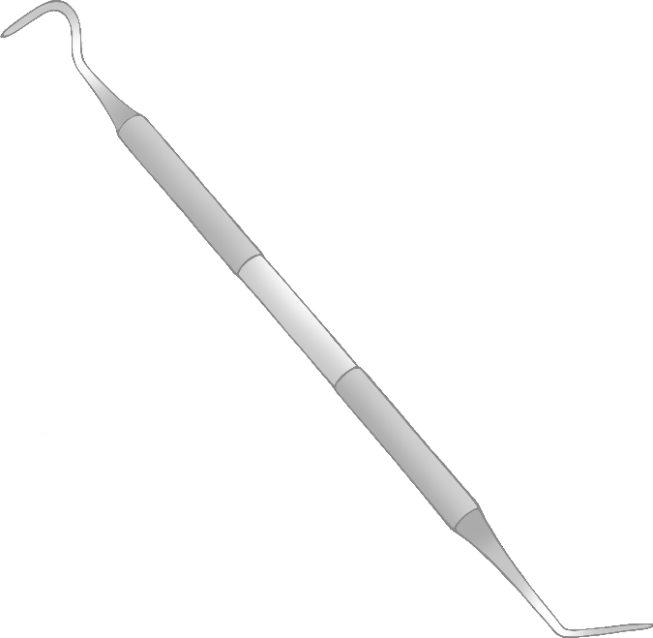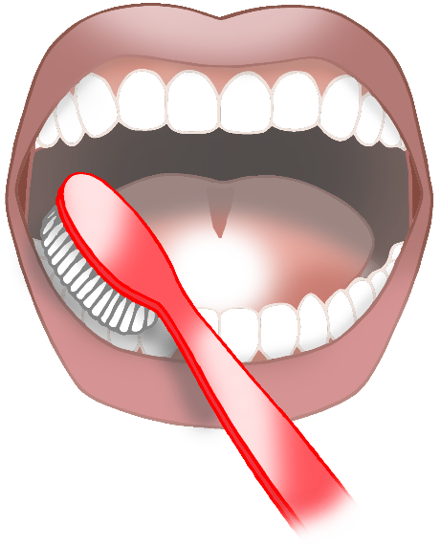

Brush teeth

© 2021 Little Owls Resources

© 2021 Little Owls Resources

© 2021 Little Owls Resources

Mirror

Probe

Electric Toothbrush

© 2021 Little Owls Resources

© 2021 Little Owls Resources

© 2021 Little Owls Resources

Toothpaste

Tweezers

© 2021 Little Owls Resources

Dentist Chair

Suction tube

© 2021 Little Owls Resources

tooth

teeth

toothbrush

© 2021 Little Owls Resources

© 2021 Little Owls Resources

© 2021 Little Owls Resources

brush teeth

© 2021 Little Owls Resources

© 2021 Little Owls Resources

© 2021 Little Owls Resources

probe

mirror

electric toothbrush

© 2021 Little Owls Resources

© 2021 Little Owls Resources

© 2021 Little Owls Resources

toothpaste

tweezers

dentist chair

© 2021 Little Owls Resources

suction tube

© 2021 Little Owls Resources