© 2021 Little Owls Resources

Toothbrush

Tooth

Brush teeth

Mirror

Probe

Tweezers

Electric Toothbrush

Toothpaste

**Dentist Word Mat**

Teeth

Suction tube

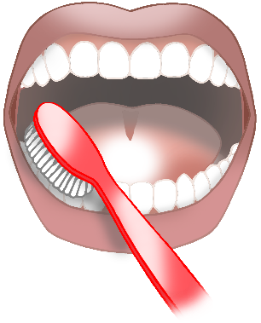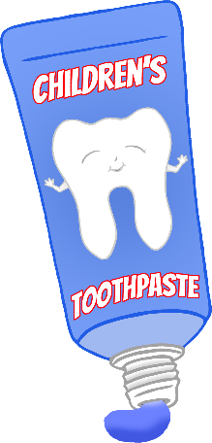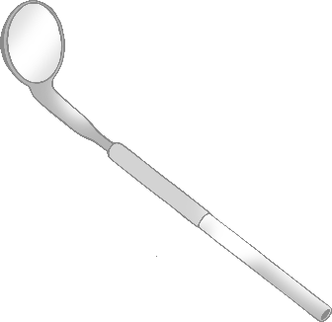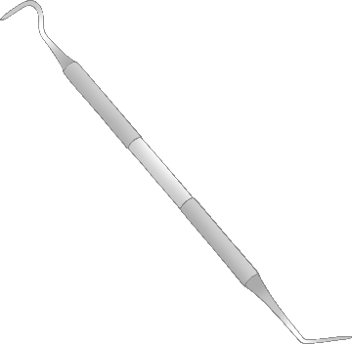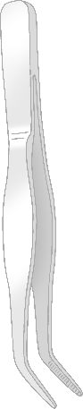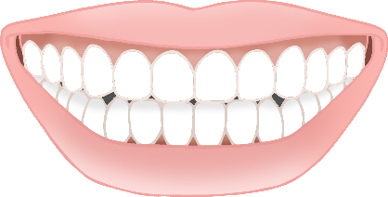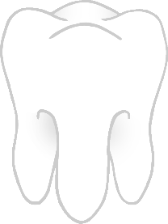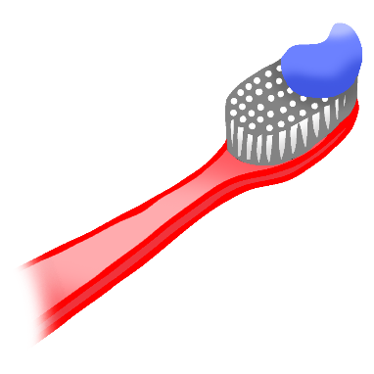

Dentist Chair

© 2021 Little Owls Resources

toothbrush

tooth

brush teeth

mirror

probe

tweezers

electric toothbrush

toothpaste

**Dentist Word Mat**

teeth

suction tube



dentist chair