© 2021 Little Owls Resources

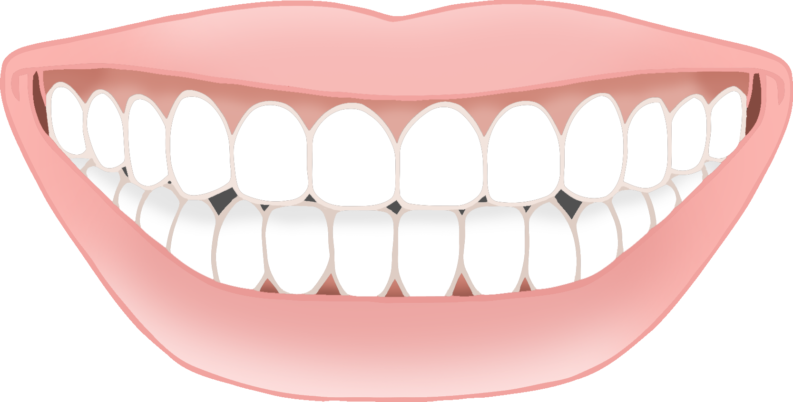

**What beautiful teeth you have!**

**Keep up the great brushing!**

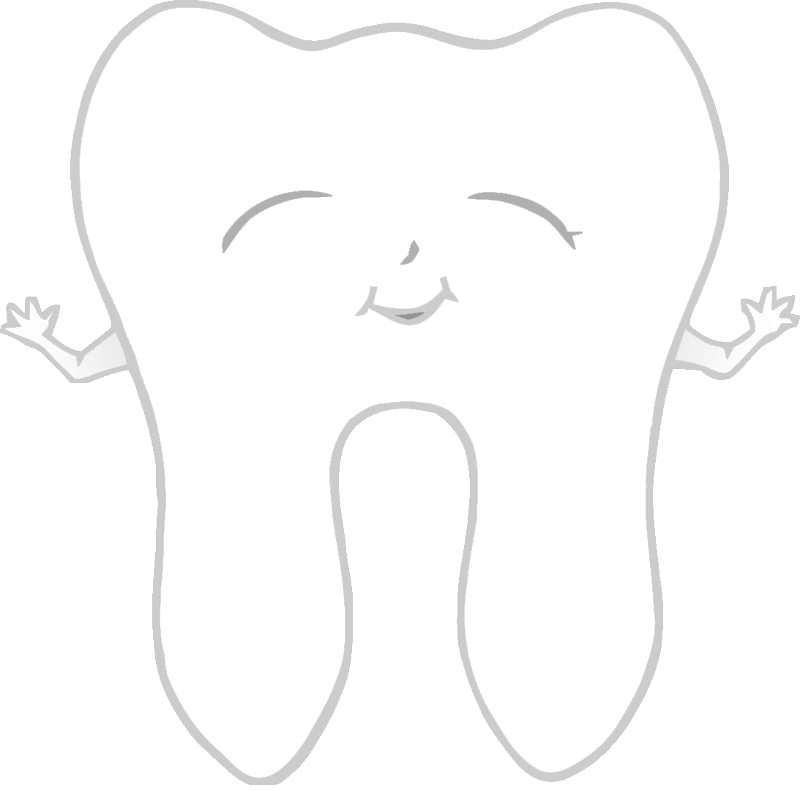

Keep me clean!

Brush your teeth!

© 2021 Little Owls Resources

**Brush your teeth for 2 minutes each time!**

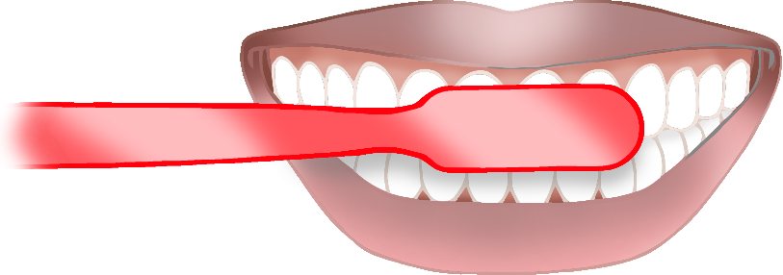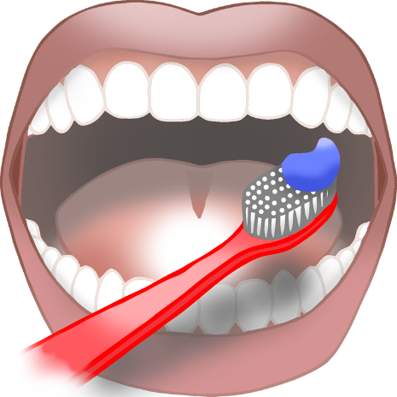

**So Clean! **

**Brush!**

**Brush!**

**Brush!**

**BrusH!**

**Brush!**

© 2021 Little Owls Resources