People Who Help Us

Dentist

The pages of this pack give some general information about the role of a dentist and some fun and engaging activities to foster and develop children’s interest in this role in society.

* Information Posters
* Information Posters (Colouring)
* Drawing/Writing Sheets
* Draw items Sheet
* Draw items Sheet (Colouring)
* Item Poster
* Item Poster (Colouring)
* Multimats for Art & Craft/Loose Parts/Playdough
* 5x 2-Piece individual items puzzles
* 1x 4-Piece all items puzzle

This pack includes:

© 2021 Little Owls Resources

© 2021 Little Owls Resources

Dentist

I’m a **dentist.**

I help people keep their teeth and gums healthy.

If someone has a problem with their teeth, I will fix it for them.

I remind people that it is very important to brush their teeth!

I have a special chair that patients sit back in during their appointment.

Dentist

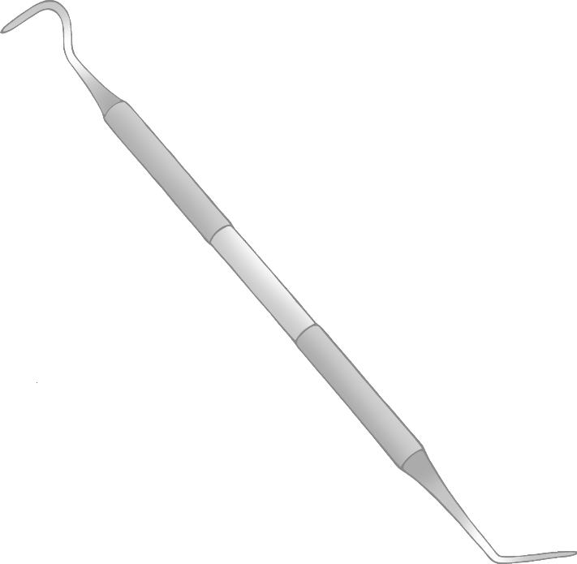

I use a suction pipe if there is too much liquid in a patient’s mouth.

I use a tool called a probe to check that the patient’s teeth and gums are healthy.

I use a mirror to look at the teeth in a patient’s mouth that are difficult to see.

© 2021 Little Owls Resources

© 2021 Little Owls Resources

**Dentist**

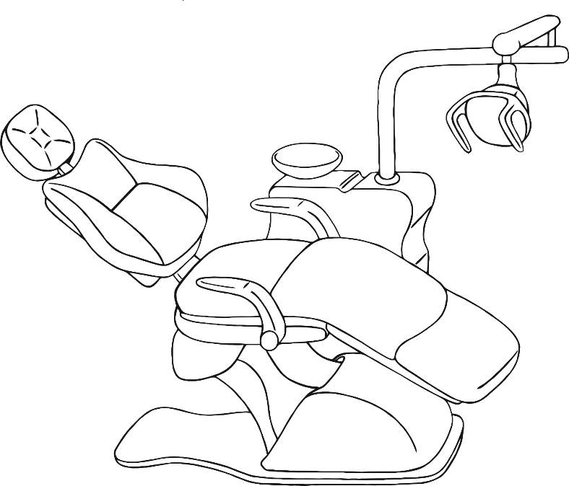

**I’m a dentist.**

**I help people keep their teeth and gums healthy.**

**If someone has a problem with their teeth, I will fix it for them.**

**I remind people that it is very important to brush their teeth!**

**I have a special chair that patients sit back in during their appointment.**

**Dentist**

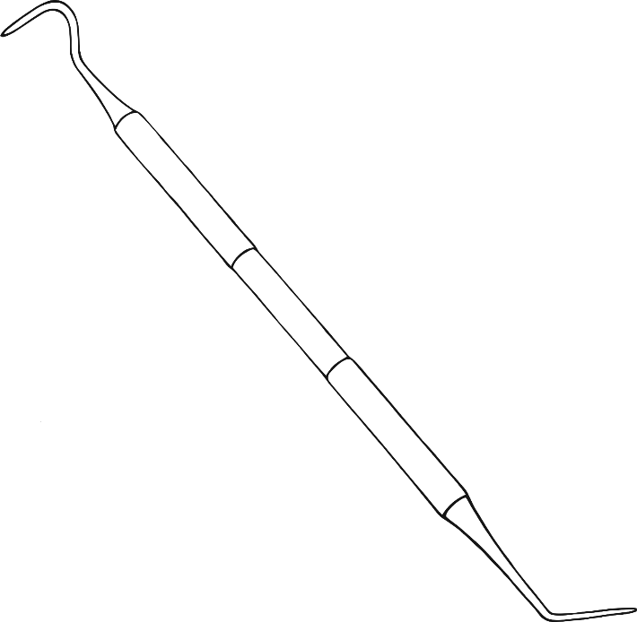

**I use a suction pipe if there is too much liquid in a patient’s mouth.**

**I use a tool called a probe to check that the patient’s teeth and gums are healthy.**

**I use a mirror to look at the teeth in a patient’s mouth that are difficult to see.**

© 2021 Little Owls Resources

© 2021 Little Owls Resources

Draw a Dentist!

© 2021 Little Owls Resources

Draw and write about a Dentist!

_________________________________________________________

© 2021 Little Owls Resources

Draw and write about a Dentist!

________________________________________________________________________________________________________________________________________________

**Can you draw the items a dentist needs?**

© 2021 Little Owls Resources

**Can you draw the items a dentist needs?**

© 2021 Little Owls Resources

Dentist

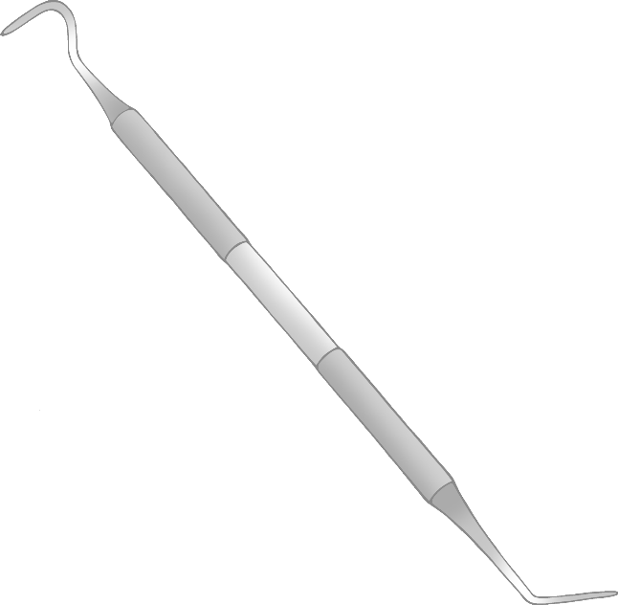

Dentist’s Chair

Probe

© 2021 Little Owls Resources

Suction Pipe

Mirror

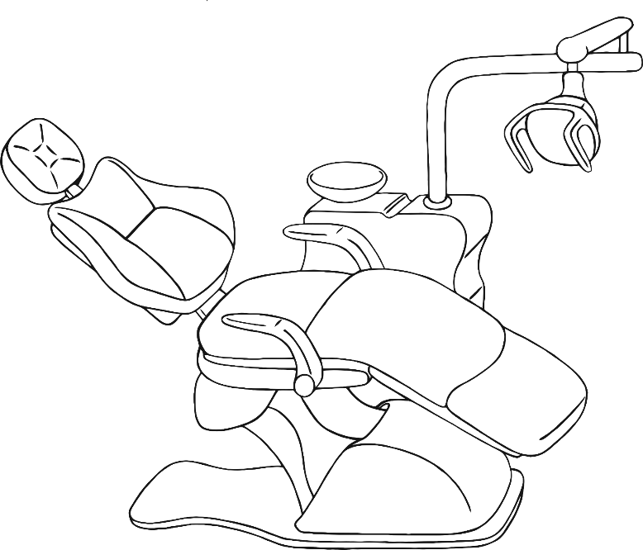

**Dentist**

© 2021 Little Owls Resources

**Probe**

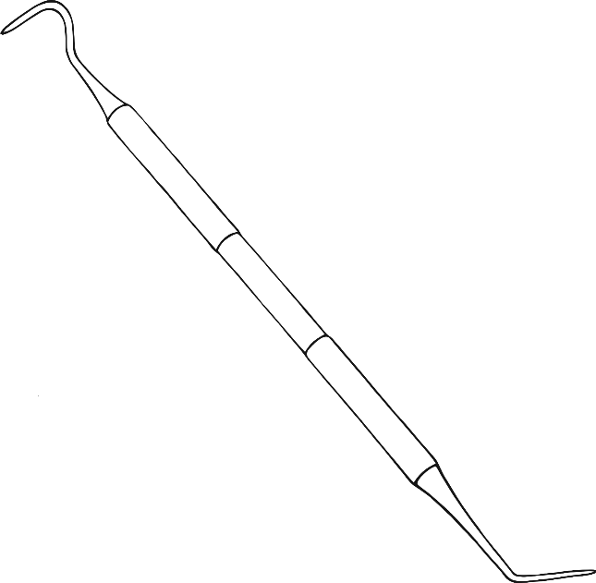

**Mirror**

**Suction Pipe**

**Dentist’s Chair**

Dentist Multimat – Dentist’s Chair

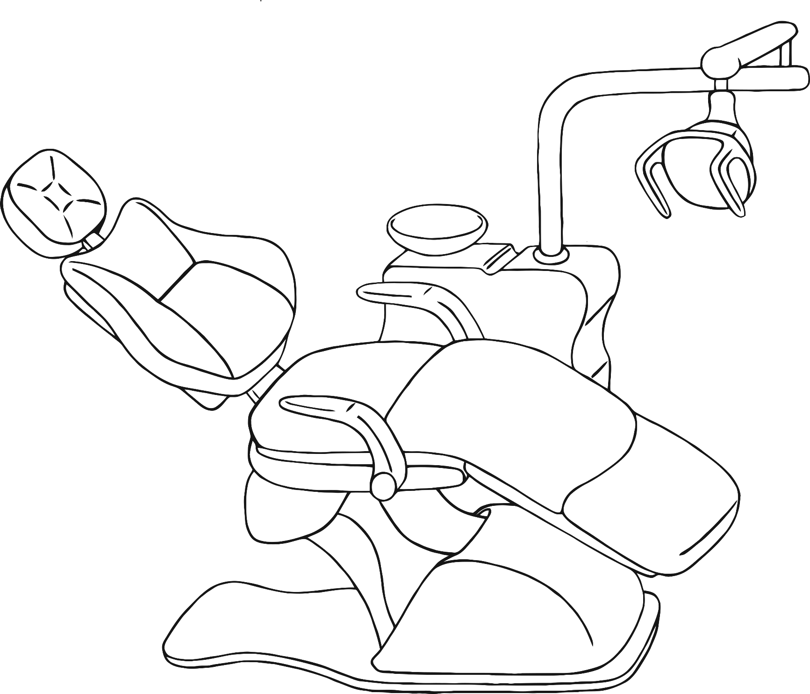

© 2021 Little Owls Resources

Dentist Multimat – Suction Pipe

© 2021 Little Owls Resources

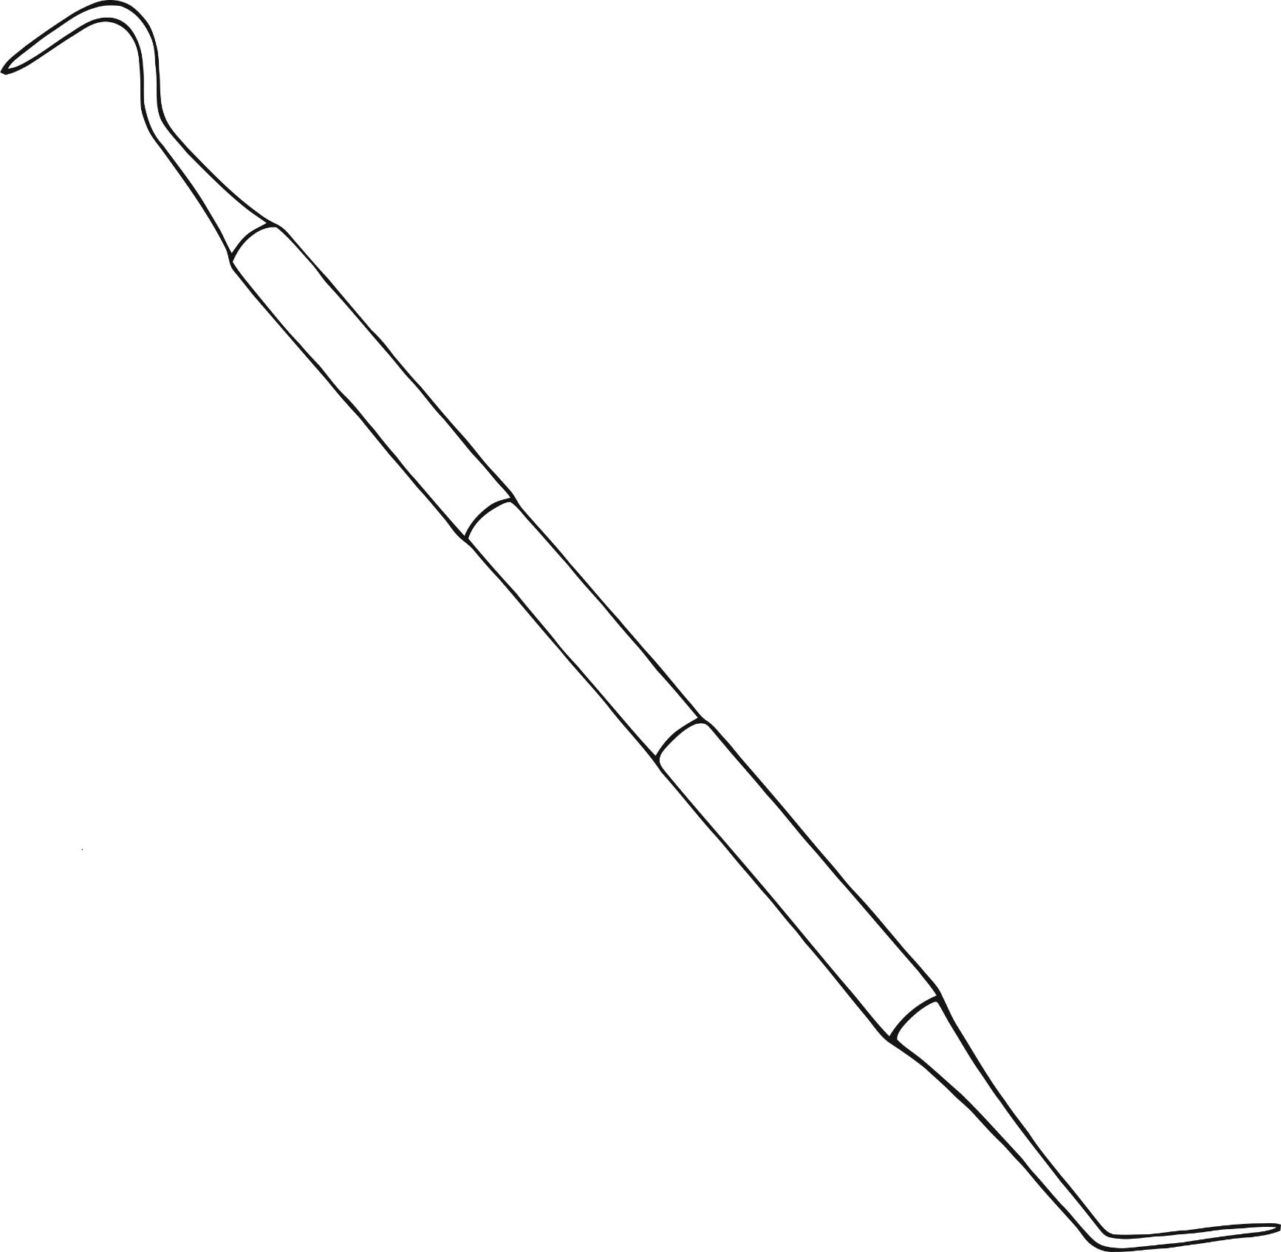

Dentist Multimat – Probe

© 2021 Little Owls Resources

Dentist Multimat – Mirror

© 2021 Little Owls Resources

© 2021 Little Owls Resources

© 2021 Little Owls Resources

© 2021 Little Owls Resources

© 2021 Little Owls Resources

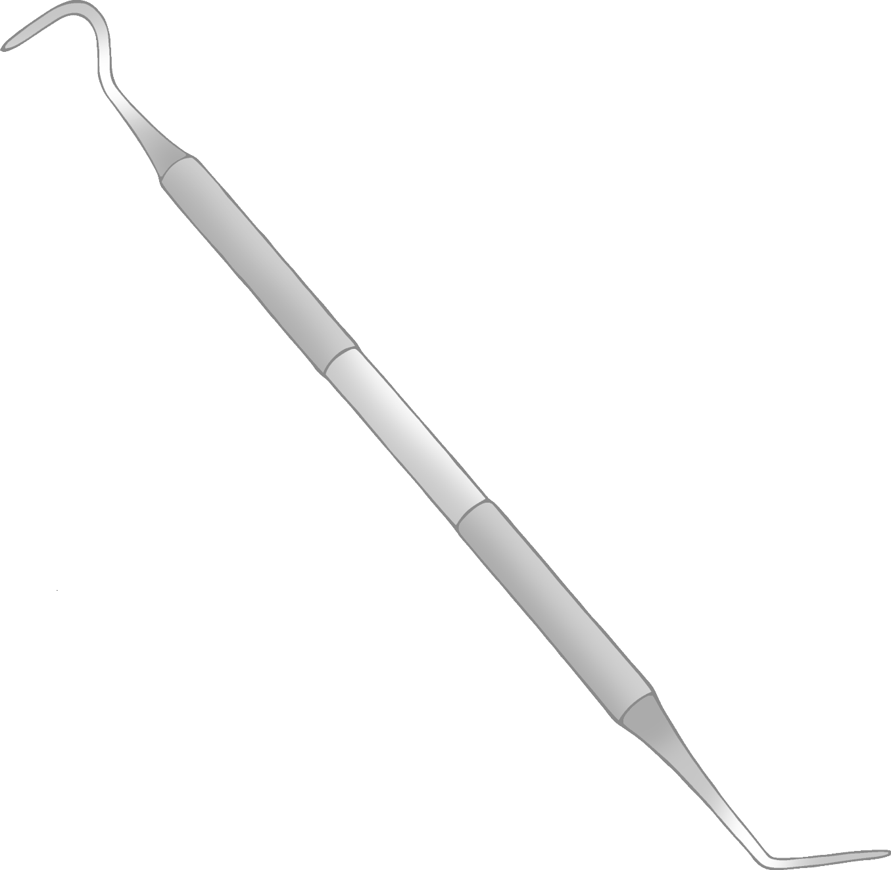

© 2021 Little Owls Resources

**Dentist**

© 2021 Little Owls Resources

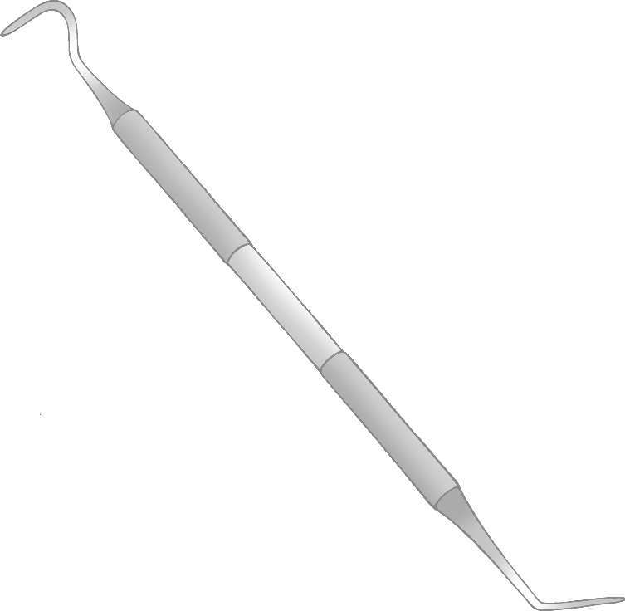

Dentist’s Chair

Suction Pipe

Mirror

Probe