Daisy Dice Game

\* 1-6 dice required \*

Children to roll dice and then put the right number of spots on Daisy the cow.

Cut and laminate the grey circles below.

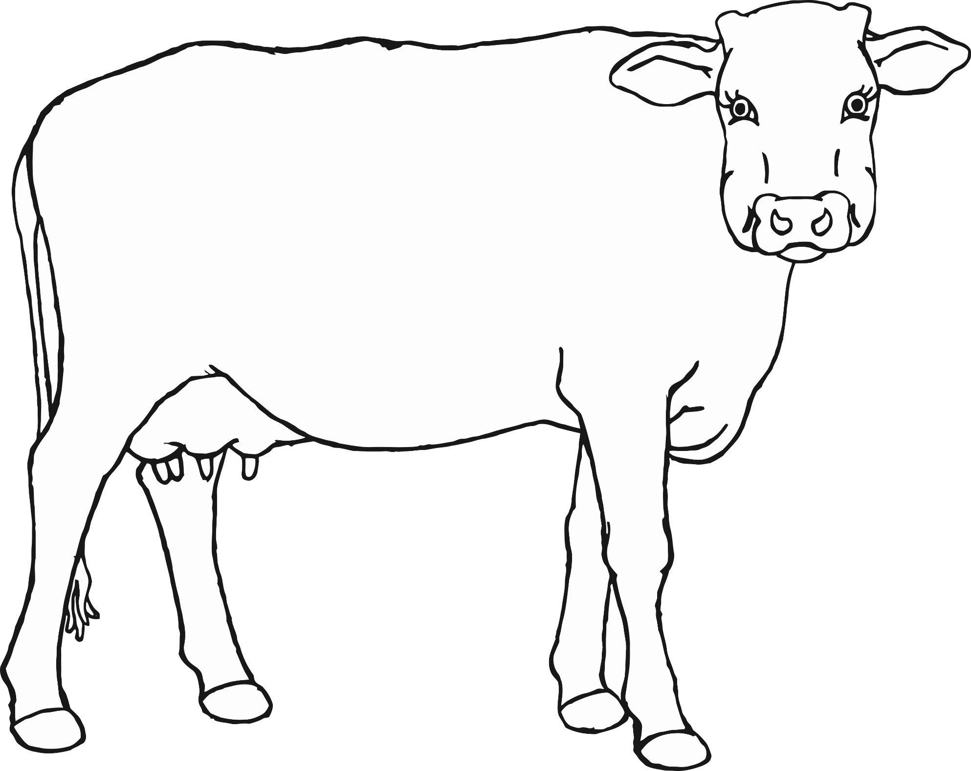

How many spots?