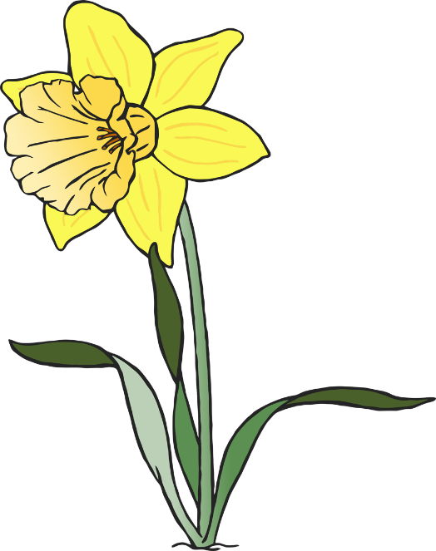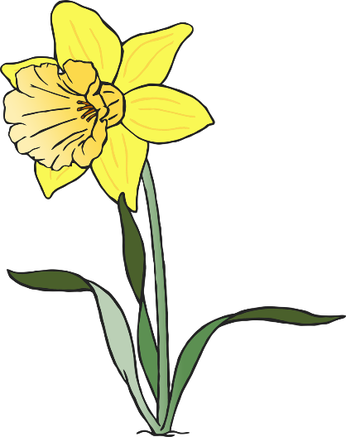

at

© 2020 Little Owls Resources

as

© 2020 Little Owls Resources

an

© 2020 Little Owls Resources

a

© 2020 Little Owls Resources



of

© 2020 Little Owls Resources

on

© 2020 Little Owls Resources

off

© 2020 Little Owls Resources

can

© 2020 Little Owls Resources



if

© 2020 Little Owls Resources

is

© 2020 Little Owls Resources

in

© 2020 Little Owls Resources

it

© 2020 Little Owls Resources



dad

© 2020 Little Owls Resources

back

© 2020 Little Owls Resources

had

© 2020 Little Owls Resources

and

© 2020 Little Owls Resources



get

© 2020 Little Owls Resources

him

© 2020 Little Owls Resources

big

© 2020 Little Owls Resources

his

© 2020 Little Owls Resources



but

© 2020 Little Owls Resources

the

© 2020 Little Owls Resources

put

© 2020 Little Owls Resources

to

© 2020 Little Owls Resources



not

© 2020 Little Owls Resources

up

© 2020 Little Owls Resources

got

© 2020 Little Owls Resources

mum

© 2020 Little Owls Resources



I

no

© 2020 Little Owls Resources

© 2020 Little Owls Resources

go

into

© 2020 Little Owls Resources

© 2020 Little Owls Resources