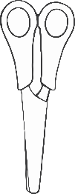

© 2021 Little Owls Resources

**Recycling**

Cut, sort and stick!

© 2021 Little Owls Resources

**Sort for recycling!**

**Glass**

**Food Waste**

**Garden Waste**

**Metal**

**Paper or Card**