**Create your own zoo map!**

© 2021 Little Owls Resources

**My Zoo Map**

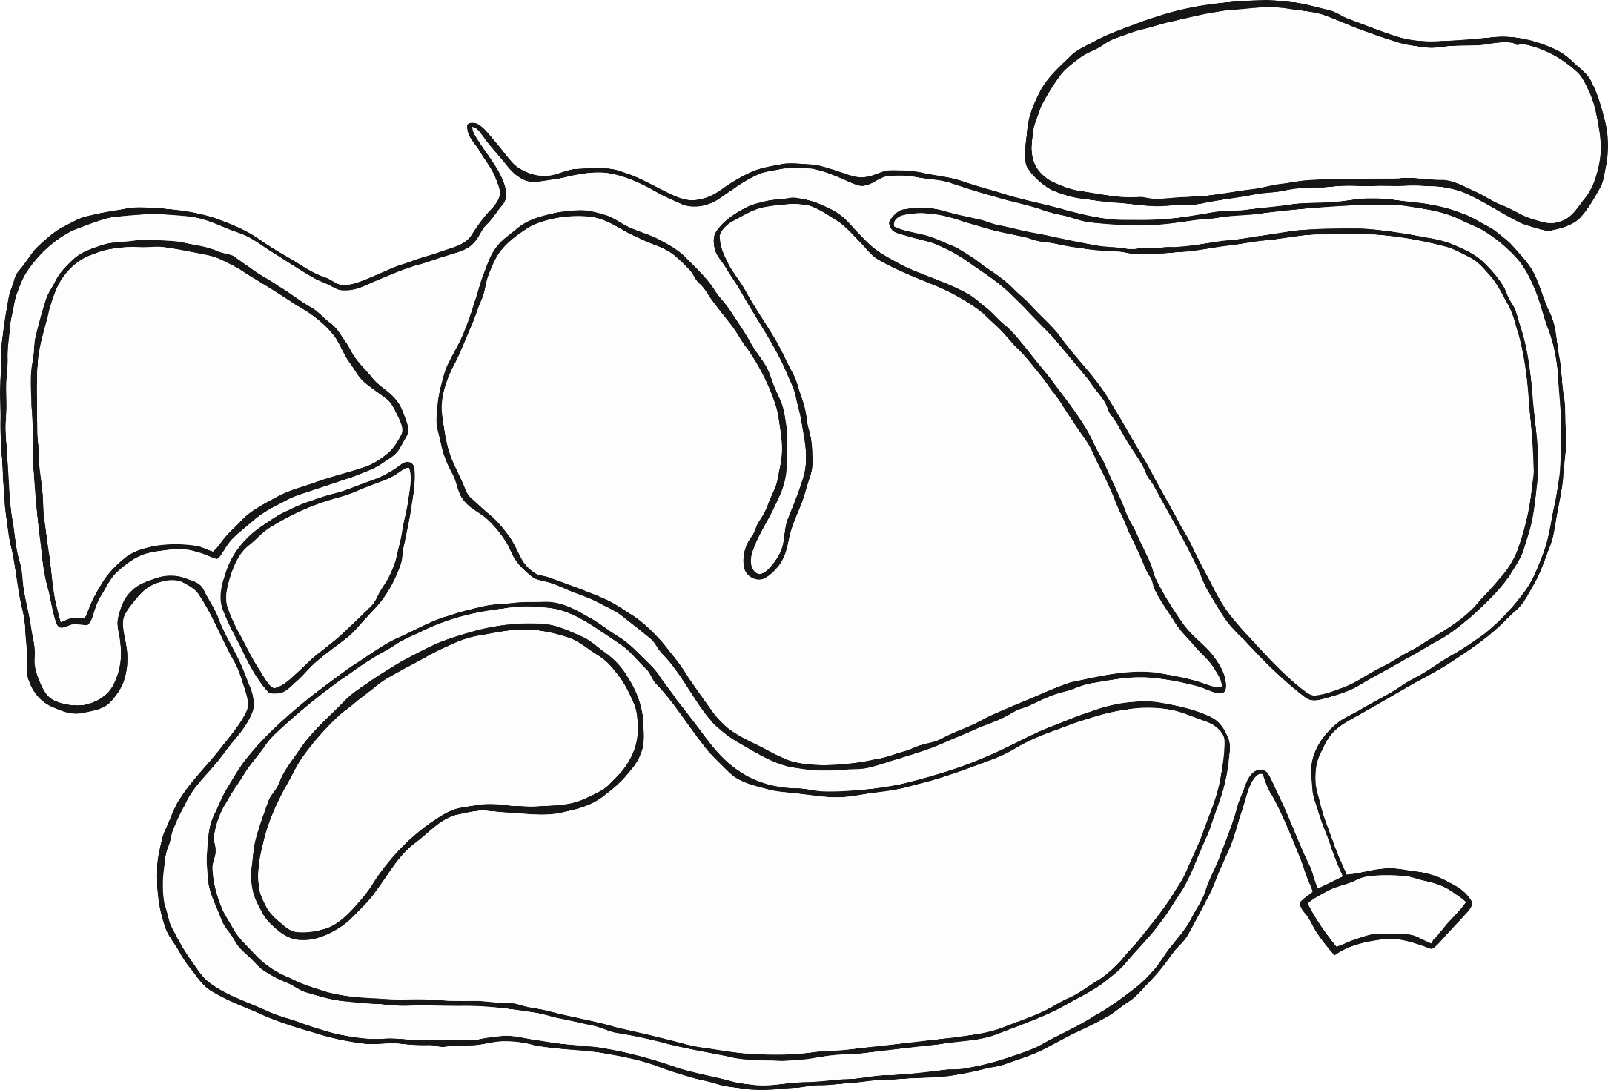

© 2021 Little Owls Resources

**My Zoo Map**