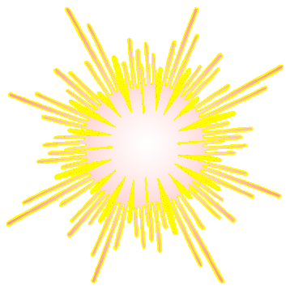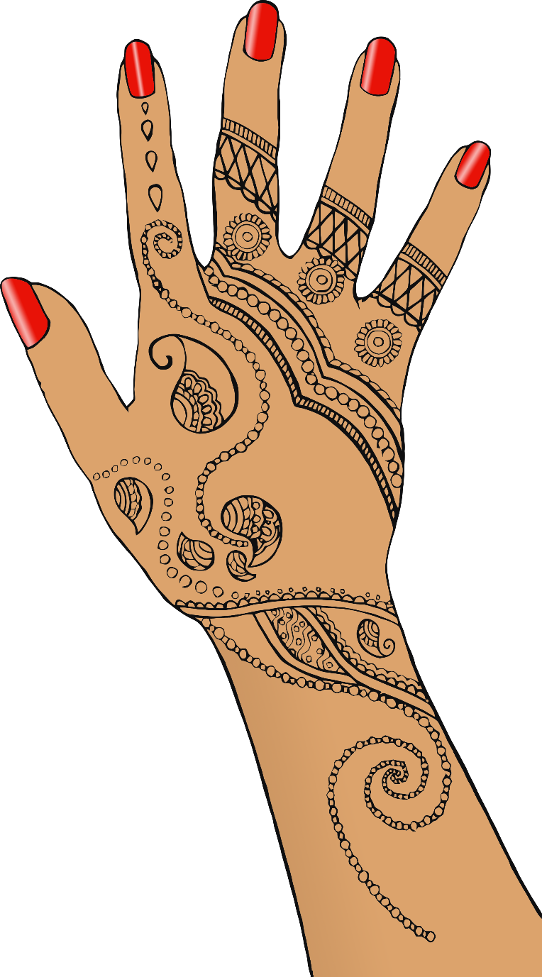

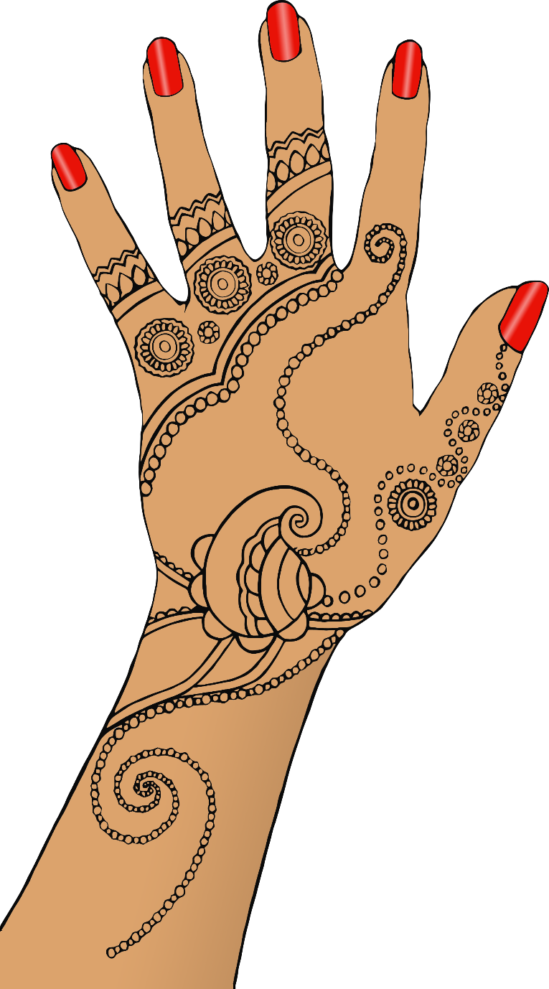

**Create your own**

**mehndi designs**

**for Diwali!**





