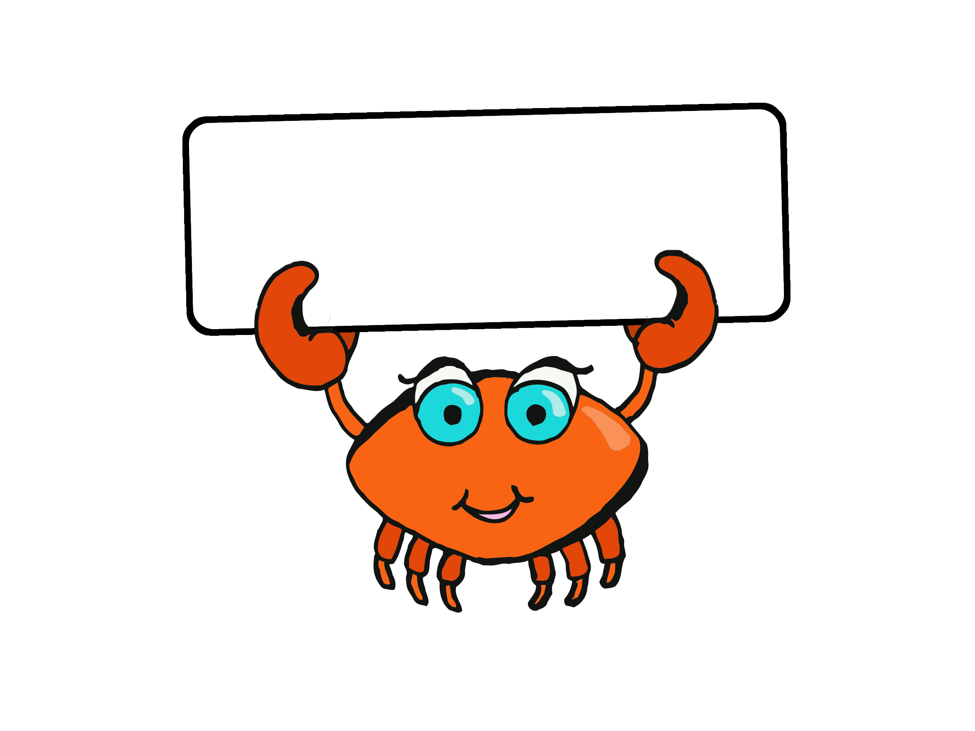

a



an



as



and



at



back



big



but



can



dad



get



go



got



had



him



his



I



if



in



into



is



it



mum



no



not



of



off



on



the



two



up