**Cow body parts**

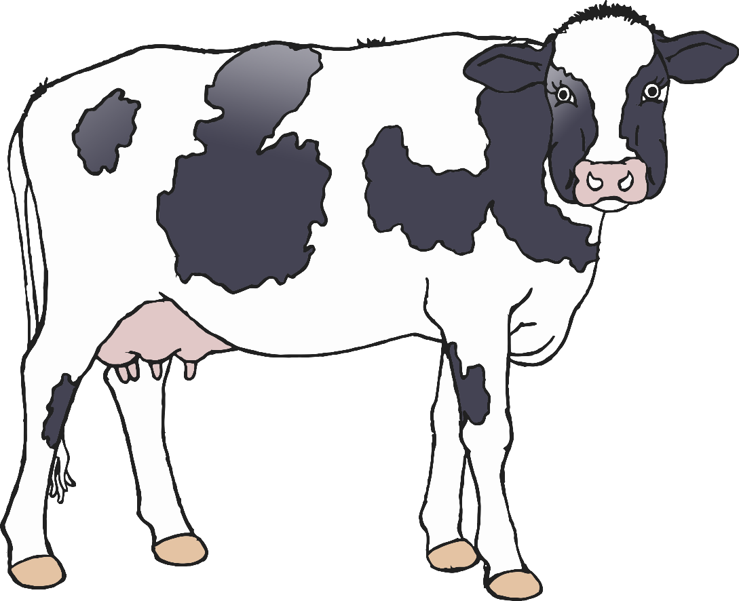

© 2021 Little Owls Resources



b

e

h

u

t

**Cow body parts**

© 2021 Little Owls Resources



back

ear

hoof

udder

tail

**Cow body parts**

© 2021 Little Owls Resources