Counting Minibeasts

Count how many minibeasts are in the magnifying glass, then write your answer in the box.

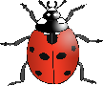

5



Counting Minibeasts 1



Counting Minibeasts 2



Counting Minibeasts 3



Counting Minibeasts 4



Counting Minibeasts

