**Cough or Sneeze**

**Tissue or Sleeve**

**\***

© 2020 Little Owls Resources

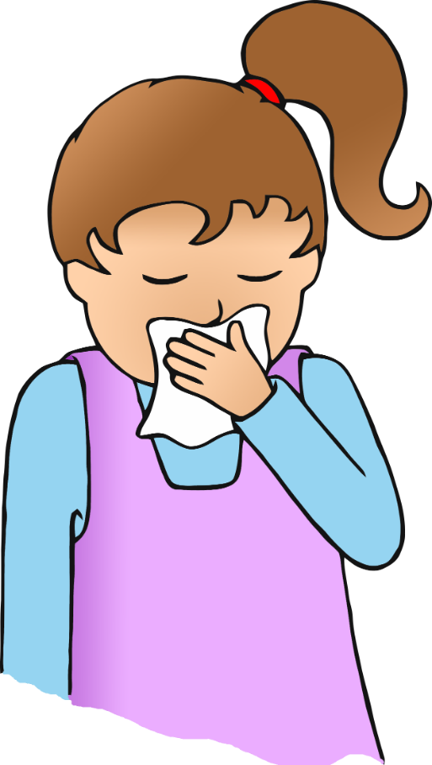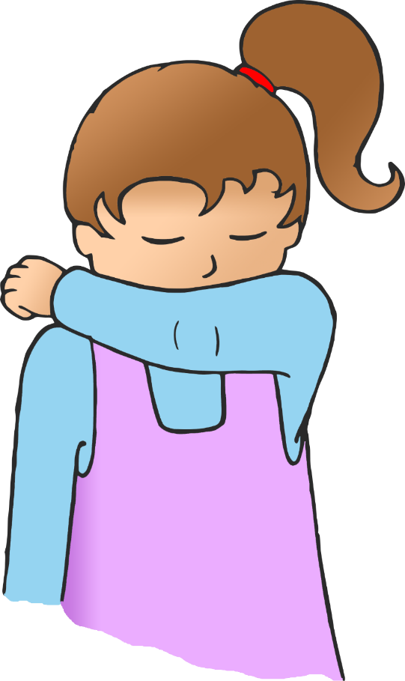



**\***

**Cough or Sneeze**

**Tissue or Sleeve**

© 2020 Little Owls Resources