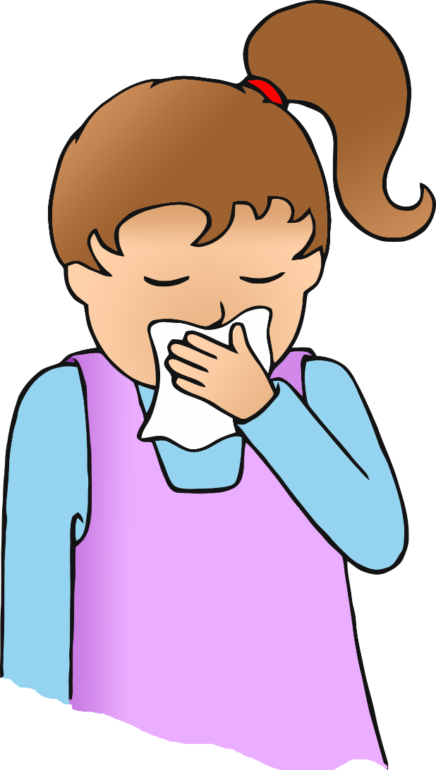

**After you cough, sneeze or blow your nose…**

**Wash your hands!**