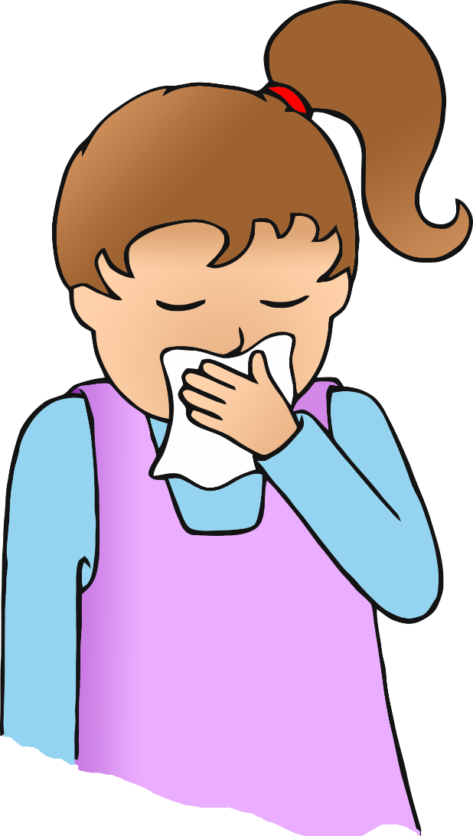

**Wash your hands!**

**After you cough, sneeze or blow your nose…**

© 2020 Little Owls Resources