**Sneeze or cough into a tissue, then throw it away and wash your hands.**

© 2020 Little Owls Resources

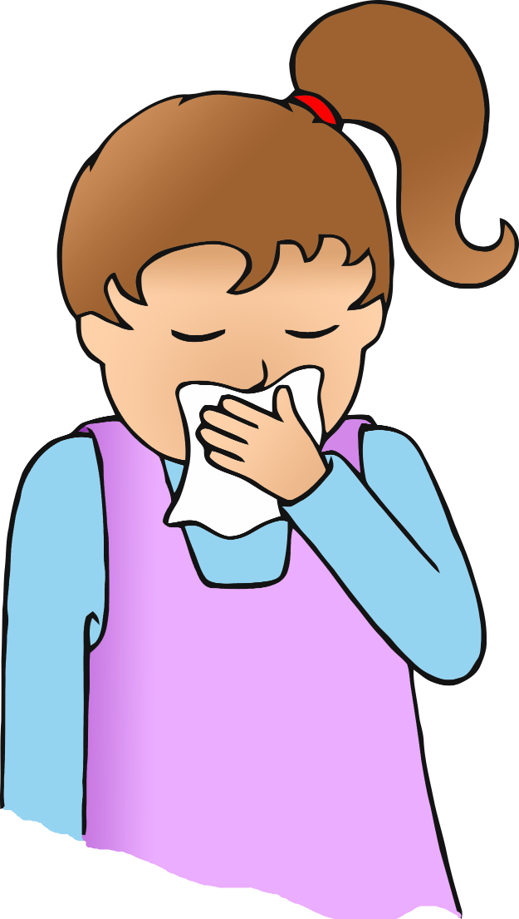

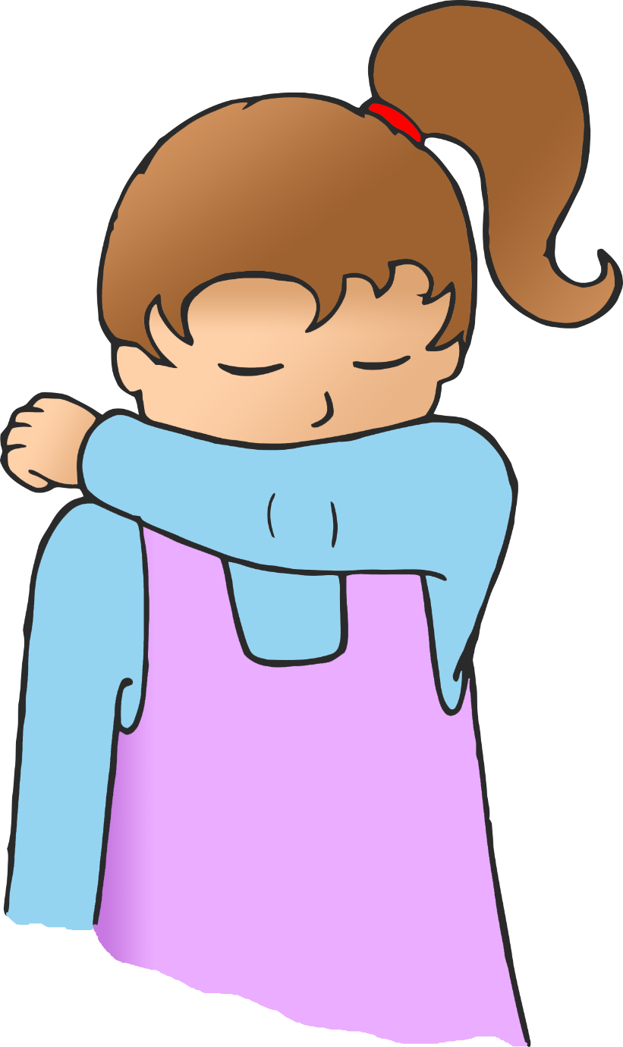

© 2020 Little Owls Resources

**If you don’t have a tissue, sneeze or cough into your sleeve.**



**If you don’t have a tissue, sneeze or cough into the crook of your elbow.**

© 2020 Little Owls Resources