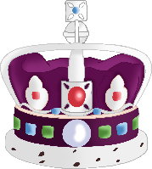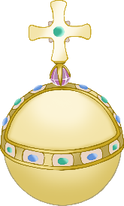

© 2022 Little Owls Resources

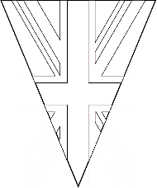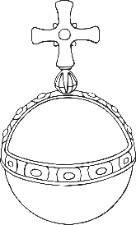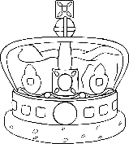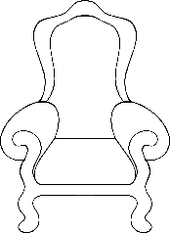

© 2022 Little Owls Resources

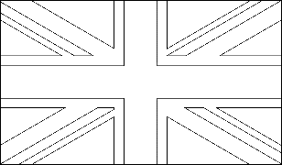

____________________________________________________________________



© 2022 Little Owls Resources

____________________________________________________________________



© 2022 Little Owls Resources



____________________________________________________________________________________________________________________________________________



© 2022 Little Owls Resources



© 2022 Little Owls Resources



____________________________________________________________________________________________________________________________________________

____________________________________________________________



© 2022 Little Owls Resources



© 2022 Little Owls Resources



____________________________________________________________