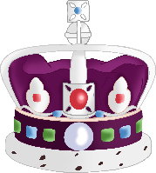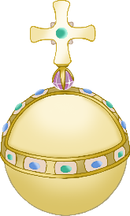

© 2022 Little Owls Resources

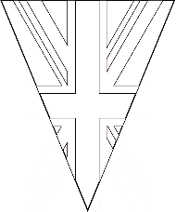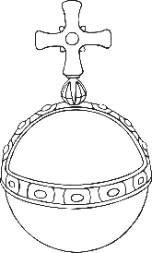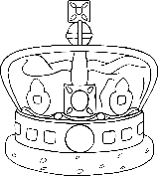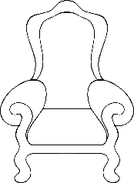

© 2022 Little Owls Resources

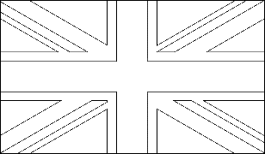



© 2022 Little Owls Resources

________________________________________________________



© 2022 Little Owls Resources



________________________________________________________



© 2022 Little Owls Resources

____________________________________________________________________________________________________________________________________________



© 2022 Little Owls Resources



____________________________________________________________________________________________________________________________________________



© 2022 Little Owls Resources

_________________________________________________________



© 2022 Little Owls Resources



_________________________________________________________