**Help the corgi get to the castle!** (1)

© 2022 Little Owls Resources

**Help the corgi get to the castle!** (2)

© 2022 Little Owls Resources

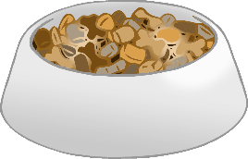

**Help the corgi get to the castle!** (3)

© 2022 Little Owls Resources

**Help the corgi get to the castle!** (4)

© 2022 Little Owls Resources