**Help the corgis get to the castle!** (1)

© 2022 Little Owls Resources

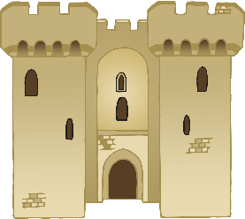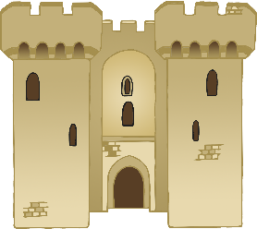

**Help the corgis get to the castle!** (2)

© 2022 Little Owls Resources