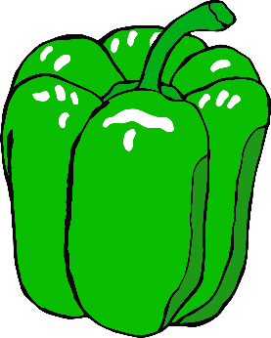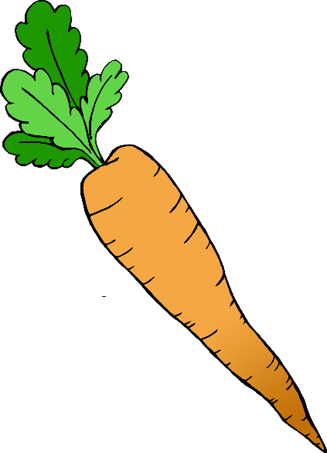

**Before cooking…**

**Wash your hands!**