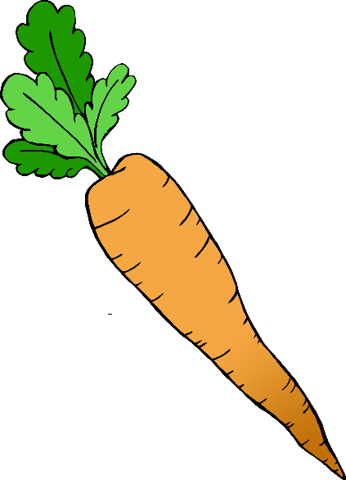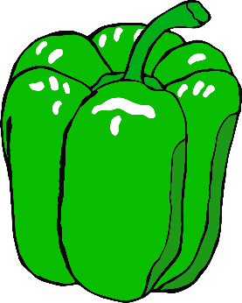

**Wash your hands!**

**Before cooking…**

© 2020 Little Owls Resources