**Construction Word Mat**

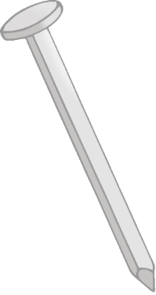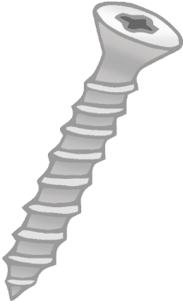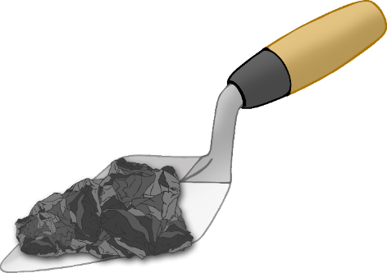

bricks

hard hat

cone

nail

screw

cement

drill

sign

hammer

toolbox

digger

builders

© 2022 Little Owls Resources