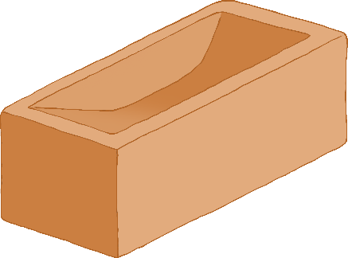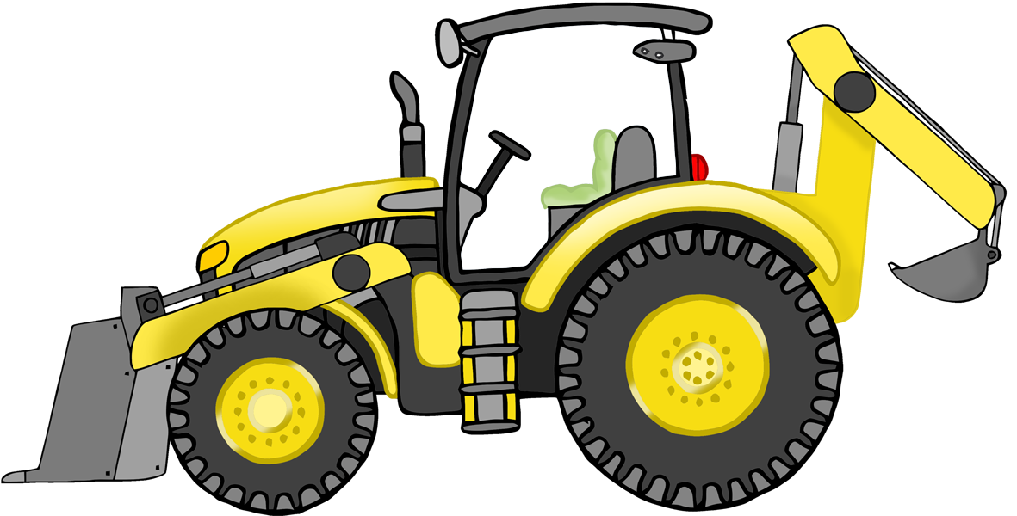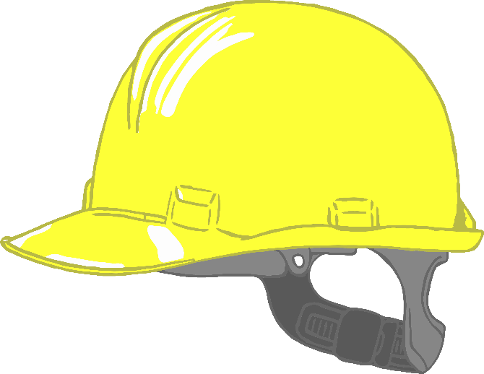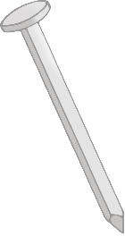

CONSTRUCTION

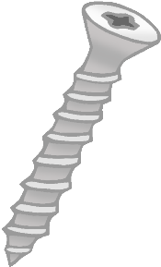

SITE

© 2022 Little Owls Resources

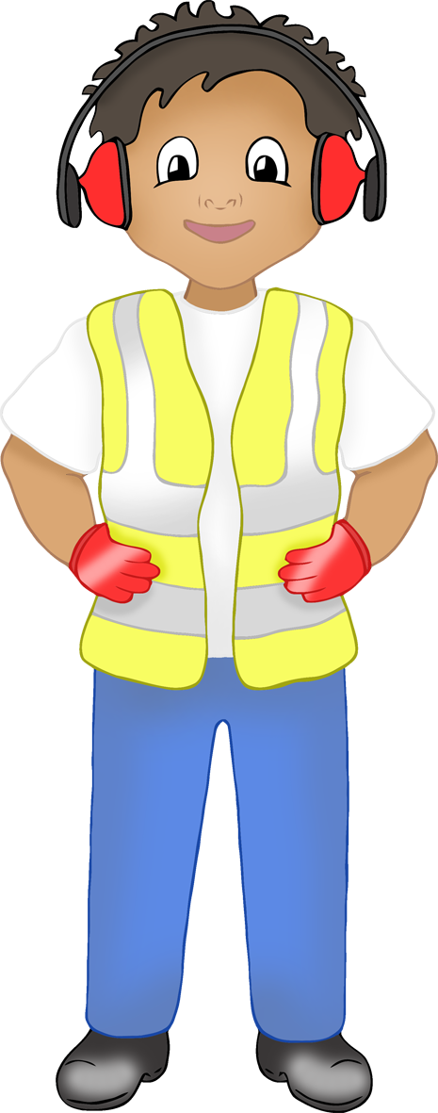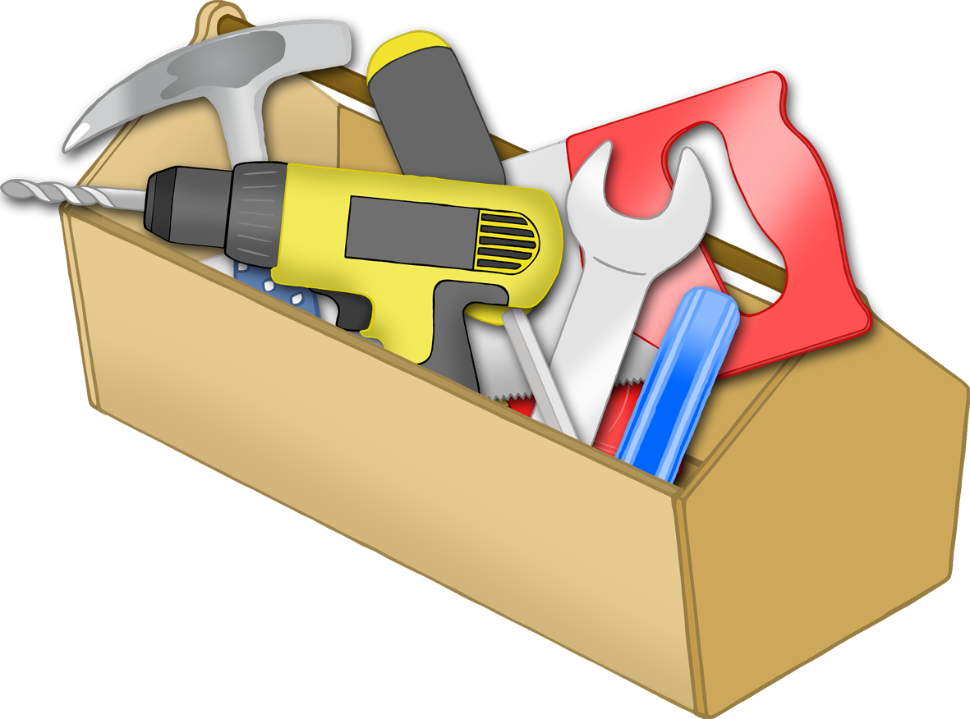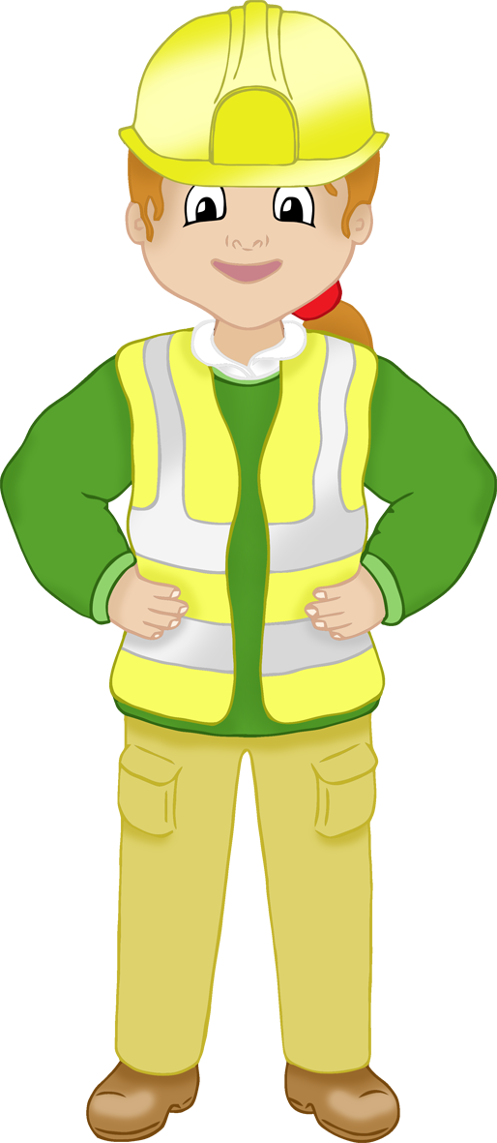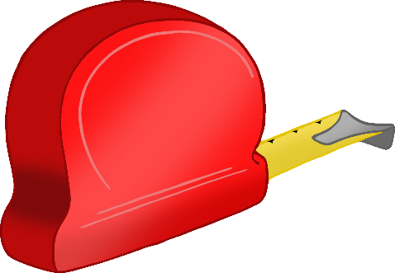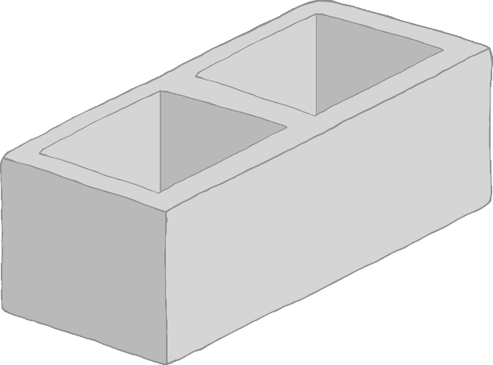

SITE



BUILDING



© 2022 Little Owls Resources



N.B. The road sign above is Crown Copyright

N.B. The road signs above is Crown Copyright

**Builder**

© 2022 Little Owls Resources

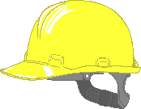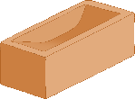

**Builder**

© 2022 Little Owls Resources



**Builder**

© 2022 Little Owls Resources



**Builder**

© 2022 Little Owls Resources



0

**Construction Worker**

© 2022 Little Owls Resources

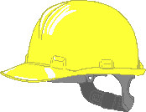

**Construction Worker**

© 2022 Little Owls Resources



**Construction Worker**

© 2022 Little Owls Resources



**Construction Worker**

© 2022 Little Owls Resources



© 2022 Little Owls Resources

High visibility jackets must be worn

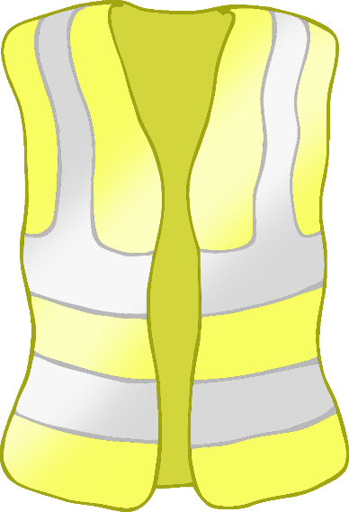

© 2022 Little Owls Resources

Protective footwear must be worn

© 2022 Little Owls Resources

Hard hats must be worn

© 2022 Little Owls Resources

Ear defenders must be worn

Warning

!

Keep out

Construction site

!

© 2022 Little Owls Resources

Warning

© 2022 Little Owls Resources

Construction site

© 2022 Little Owls Resources

Keep out

!

© 2022 Little Owls Resources

!

© 2022 Little Owls Resources

!

© 2022 Little Owls Resources

!

© 2022 Little Owls Resources

© 2022 Little Owls Resources

!

!

© 2022 Little Owls Resources

Site Office

© 2022 Little Owls Resources

Site Office

© 2022 Little Owls Resources

!

!

**Design a safety sign!**

© 2021 Little Owls Resources

© 2022 Little Owls Resources

No unauthorised access

© 2022 Little Owls Resources

Building Blueprint

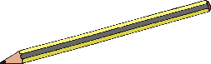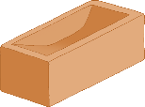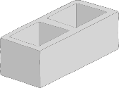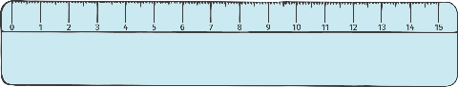

© 2022 Little Owls Resources

Construction Blueprint

© 2022 Little Owls Resources

Construction

Notes

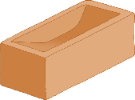

© 2022 Little Owls Resources

Construction

Notes



© 2022 Little Owls Resources

Building

Notes



© 2022 Little Owls Resources

Building

Notes



**Construction Word Mat**

© 2022 Little Owls Resources

hard hat

toolbox

digger

builders

bricks

cone

sign

hammer

drill

cement

screw

nail

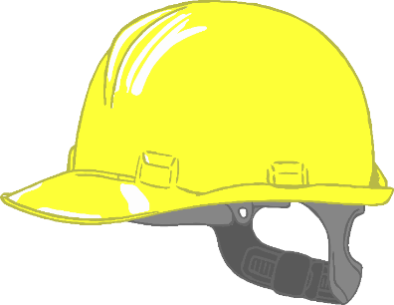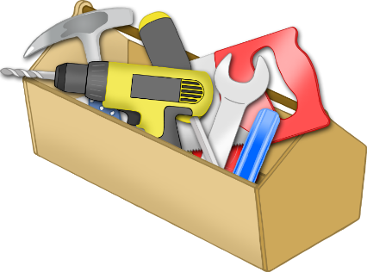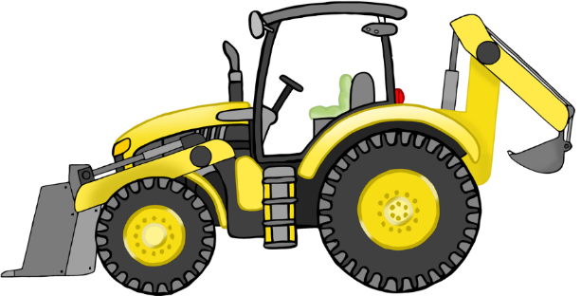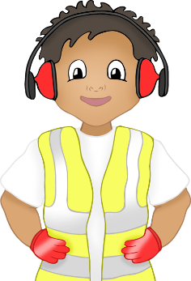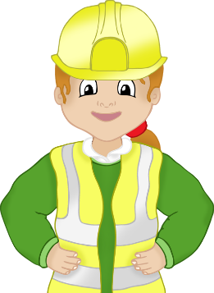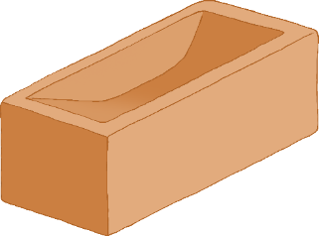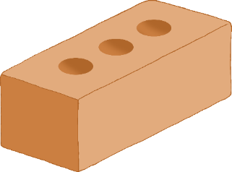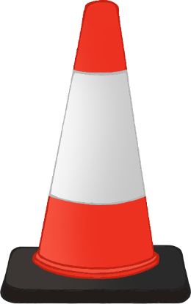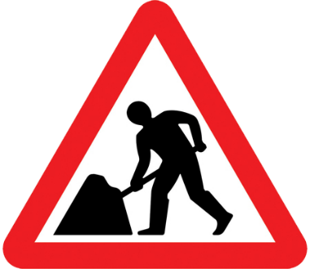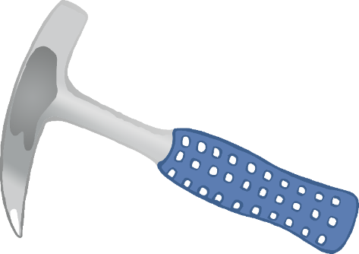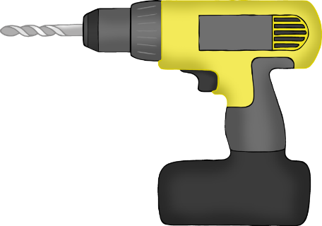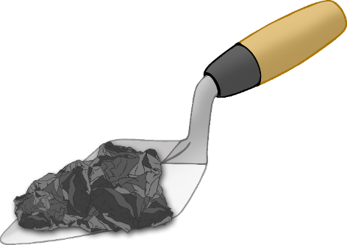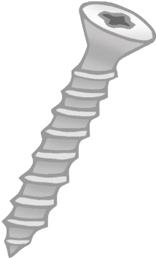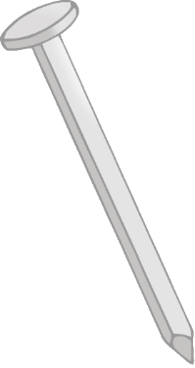

**Construction site**

© 2022 Little Owls Resources



Sign-in sheet

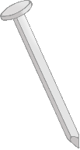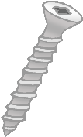

**Building site**

© 2022 Little Owls Resources



Sign-in sheet

**Building materials**

Order form

What do we need?

How big?

How many?

How will this be used?

© 2021 Little Owls Resources

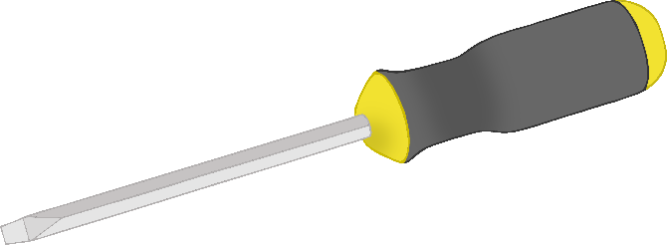

toolbox

tools

tape measure

© 2022 Little Owls Resources

© 2022 Little Owls Resources

© 2022 Little Owls Resources

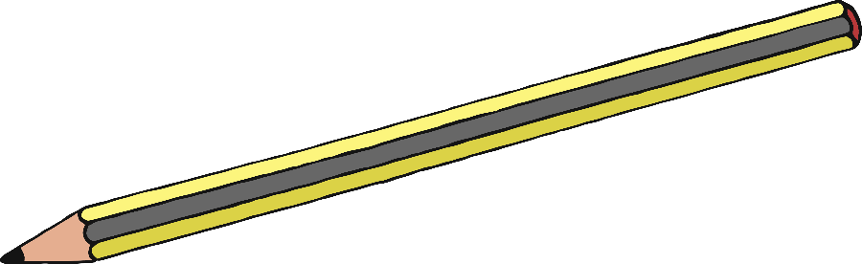

pencil

hammer

hard hat

© 2022 Little Owls Resources

© 2022 Little Owls Resources

© 2022 Little Owls Resources

© 2022 Little Owls Resources

© 2022 Little Owls Resources

© 2022 Little Owls Resources

wall

digger

bricks

builders

building

saw

© 2022 Little Owls Resources

© 2022 Little Owls Resources

© 2022 Little Owls Resources

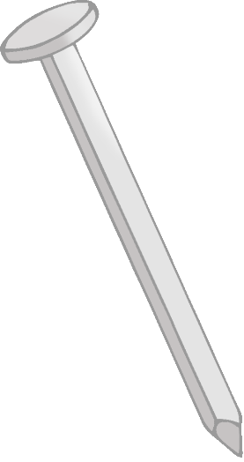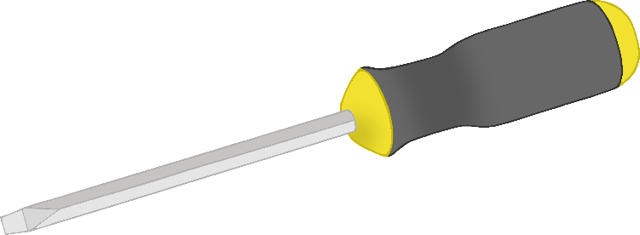

drill

screwdriver

nail

© 2022 Little Owls Resources

© 2022 Little Owls Resources

© 2022 Little Owls Resources

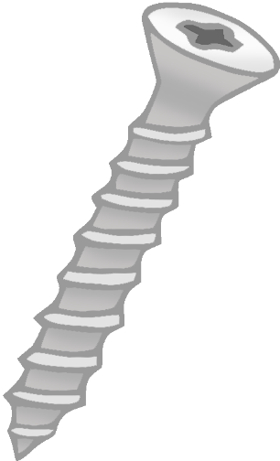

screw

spanner

high visibility jacket

© 2022 Little Owls Resources

© 2022 Little Owls Resources

© 2022 Little Owls Resources

trowel

concrete block

ear defenders

© 2022 Little Owls Resources

© 2022 Little Owls Resources

© 2022 Little Owls Resources

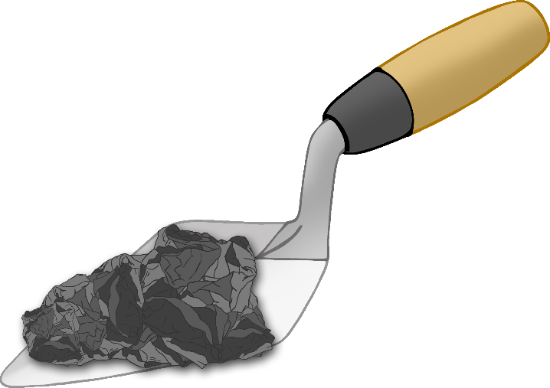

cement

work gloves

cone

© 2022 Little Owls Resources

© 2022 Little Owls Resources

© 2022 Little Owls Resources

N.B. The road sign above is Crown Copyright

signs

first aid

chisel

© 2022 Little Owls Resources

© 2022 Little Owls Resources

© 2022 Little Owls Resources

timber

wood

© 2022 Little Owls Resources

© 2022 Little Owls Resources