**Construction Multimat - Digger**

© 2022 Little Owls Resources

**Construction Multimat – Work glove**

© 2022 Little Owls Resources

**Construction Multimat - Trowel**

© 2022 Little Owls Resources

**Construction Multimat - Toolbox**

© 2022 Little Owls Resources

**Construction Multimat – Screwdriver and Spanner**

© 2022 Little Owls Resources

**Construction Multimat - Saw**

© 2022 Little Owls Resources

**Construction Multimat - Drill**

© 2022 Little Owls Resources

**Construction Multimat – Tape measure**

© 2022 Little Owls Resources

**Construction Multimat - Brick**

© 2022 Little Owls Resources

**Construction Multimat – Hard hat**

© 2022 Little Owls Resources

**Construction Multimat - Hammer**

© 2022 Little Owls Resources

**Construction Multimat – High Visibility Jacket**

© 2022 Little Owls Resources

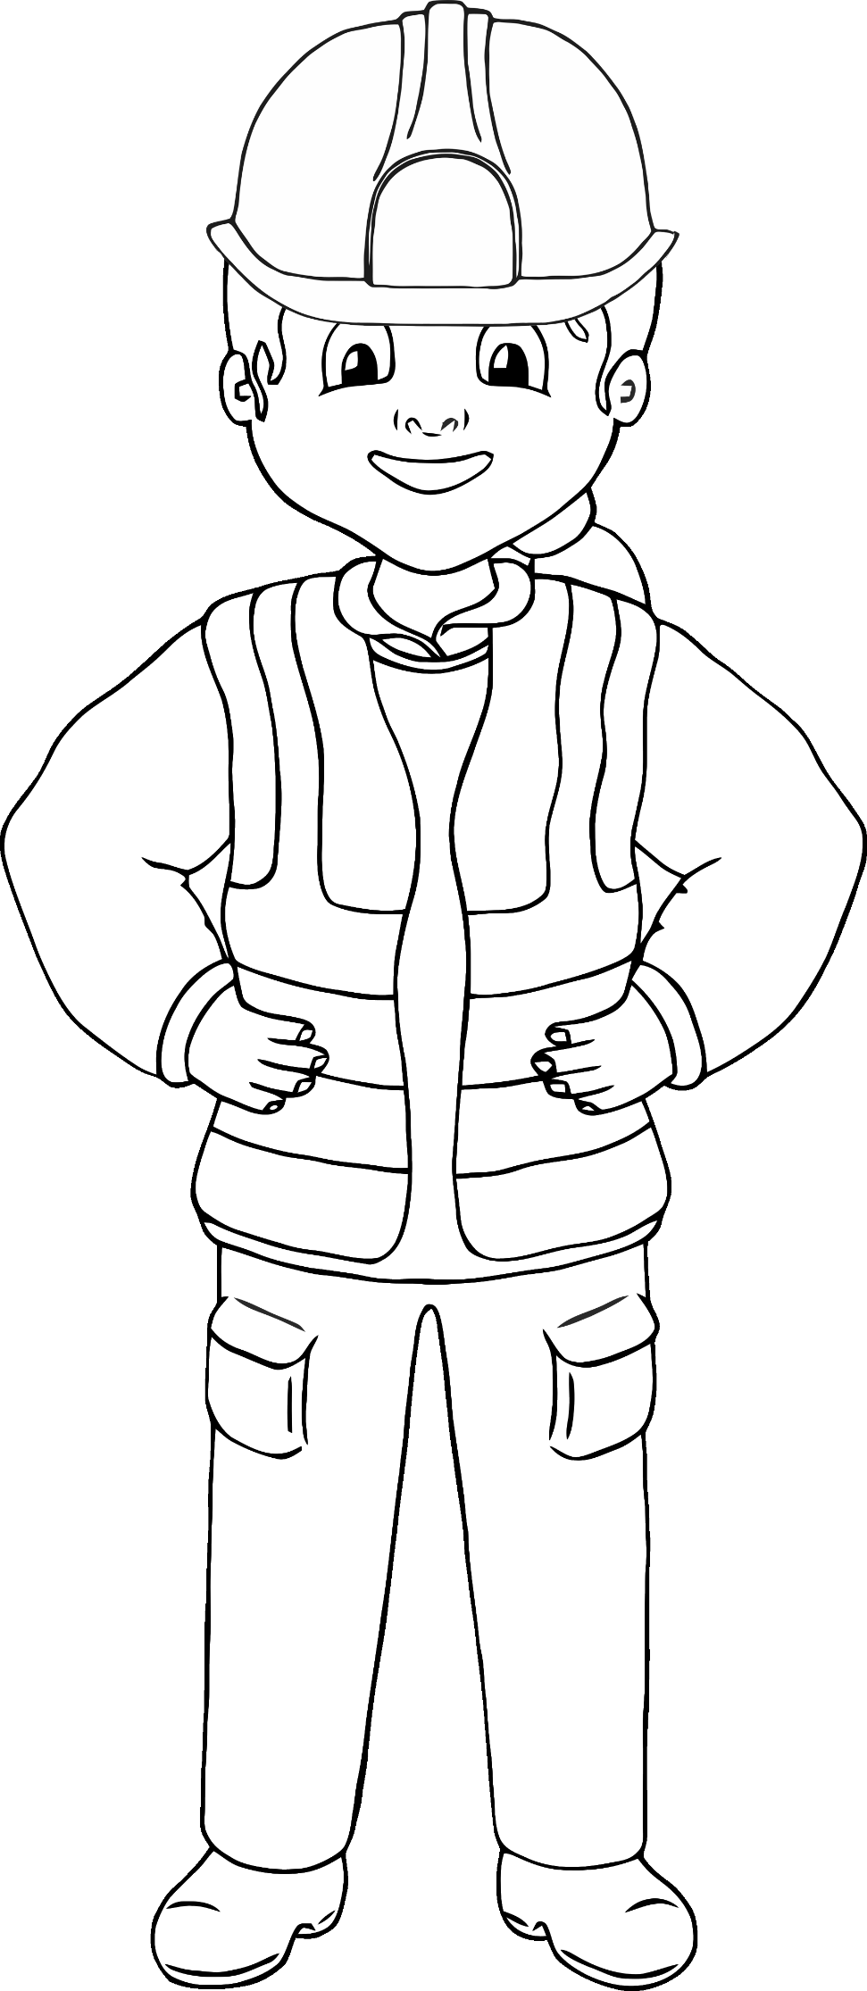

**Construction Multimat - Builder**

© 2022 Little Owls Resources

**Construction Multimat - Builder**

© 2022 Little Owls Resources