Construction Challenge Cards

© 2022 Little Owls Resources

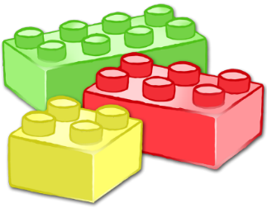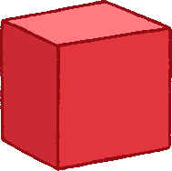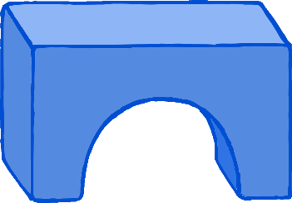

BUILD IT!

Construction Challenge Cards

© 2022 Little Owls Resources



BUILD IT!

Can you build…

…a tree?

Can you build…

…a house?

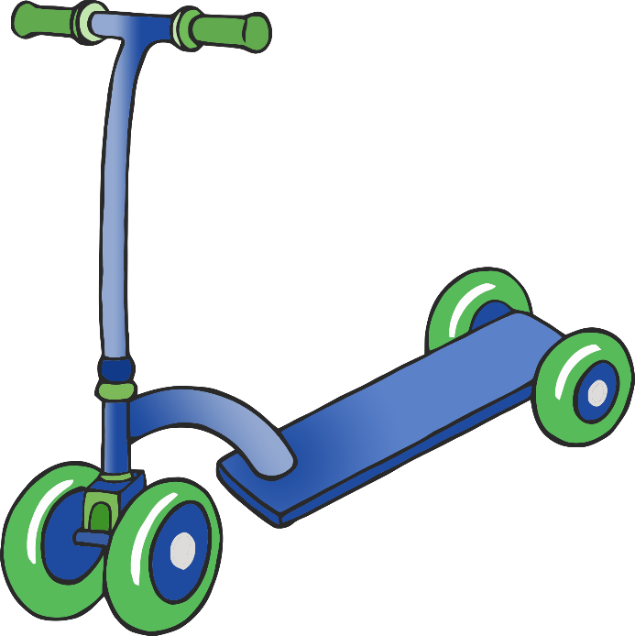

Can you build…

…a post box?

Can you build…

…a scooter?

Construction Challenge Cards

© 2022 Little Owls Resources



BUILD IT!

Construction Challenge Cards

© 2022 Little Owls Resources



BUILD IT!

Can you build…

…a brachiosaurus?

Can you build…

…a bus?

Construction Challenge Cards

© 2022 Little Owls Resources



BUILD IT!

Construction Challenge Cards

© 2022 Little Owls Resources



BUILD IT!

Can you build…

…a train?

Can you build…

…a stegosaurus?

Construction Challenge Cards

© 2022 Little Owls Resources



BUILD IT!

Construction Challenge Cards

© 2022 Little Owls Resources



BUILD IT!

Can you build…

…a tyrannosaurus rex?

Can you build…

…a lorry?

Construction Challenge Cards

© 2022 Little Owls Resources



BUILD IT!

Construction Challenge Cards

© 2022 Little Owls Resources



BUILD IT!

Can you build…

…a car?

Can you build…

…a bridge?

Construction Challenge Cards

© 2022 Little Owls Resources



BUILD IT!

Construction Challenge Cards

© 2022 Little Owls Resources



BUILD IT!

Can you build…

…a toothbrush?

Can you build…

…a motorbike?

Construction Challenge Cards

© 2022 Little Owls Resources



BUILD IT!

Construction Challenge Cards

© 2022 Little Owls Resources



BUILD IT!

Can you build…

…an aeroplane?

Can you build…

…a snail?

Construction Challenge Cards

© 2022 Little Owls Resources



BUILD IT!

Construction Challenge Cards

© 2022 Little Owls Resources



BUILD IT!

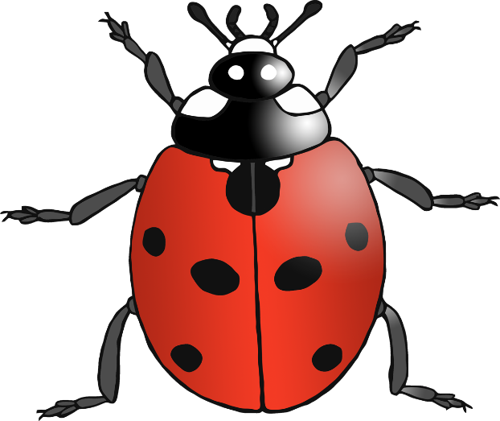

Can you build…

…a ladybird?

Can you build…

…a spaceship?

Construction Challenge Cards

© 2022 Little Owls Resources



BUILD IT!

Construction Challenge Cards

© 2022 Little Owls Resources



BUILD IT!

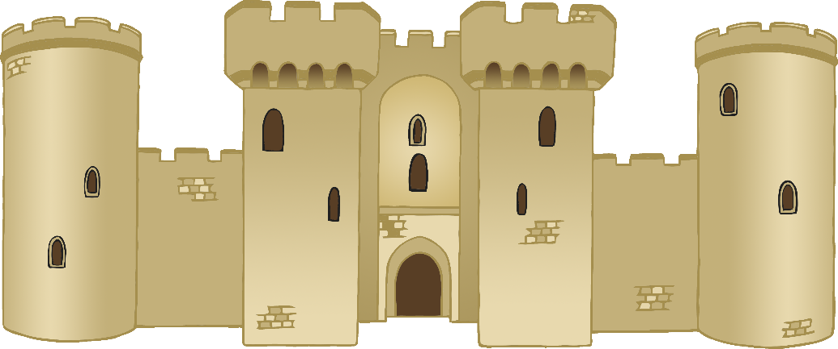

Can you build…

…a castle?

Can you build…

…a birthday cake?

Construction Challenge Cards

© 2022 Little Owls Resources



BUILD IT!

Construction Challenge Cards

© 2022 Little Owls Resources



BUILD IT!