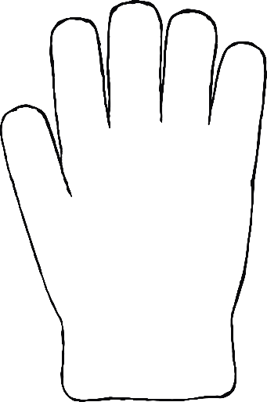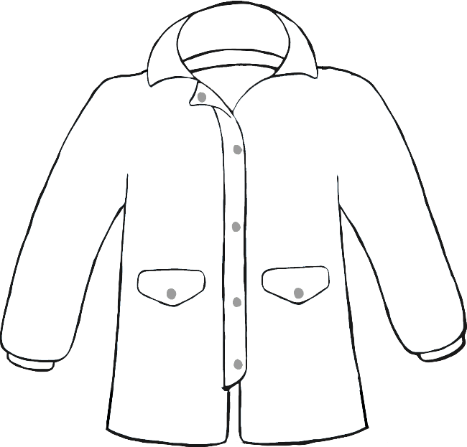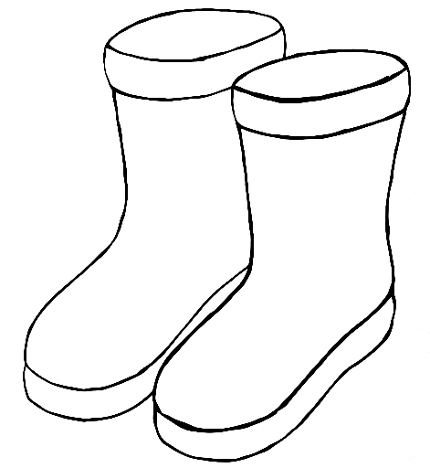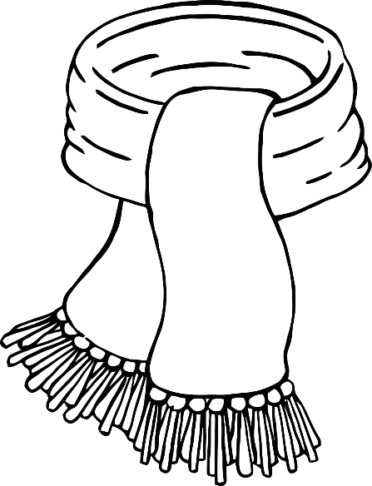

© 2021 Little Owls Resources

Colour the clothes purple.