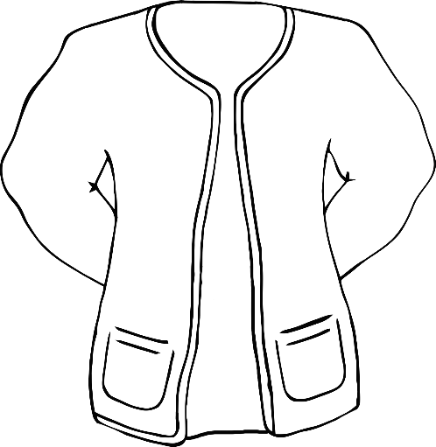

© 2022 Little Owls Resources

Colour the clothes for hot and sunny weather.

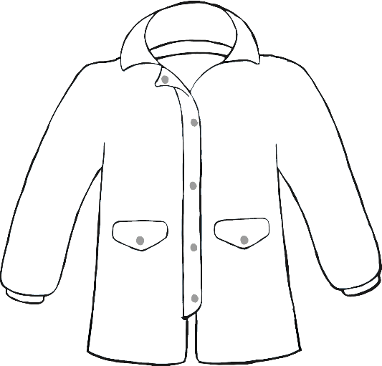

© 2022 Little Owls Resources

Colour the clothes for hot and sunny weather.

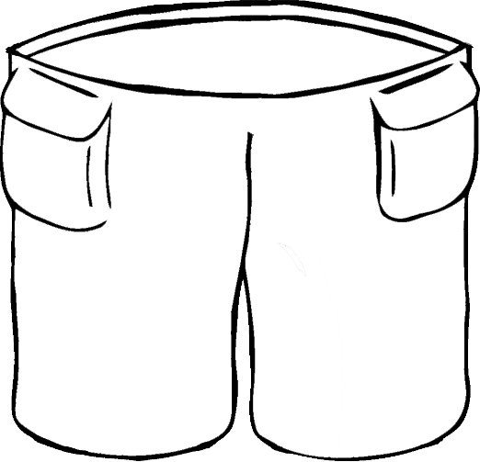

© 2022 Little Owls Resources

Colour the clothes for cold and rainy weather.

© 2022 Little Owls Resources

Colour the clothes for cold and rainy weather.