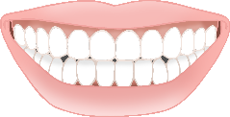

Colour the foods that are better for your teeth…

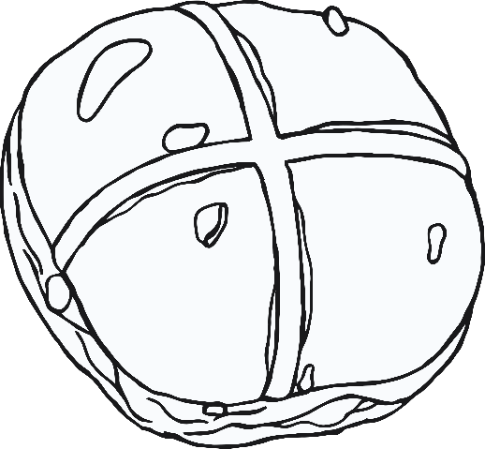

© 2021 Little Owls Resources