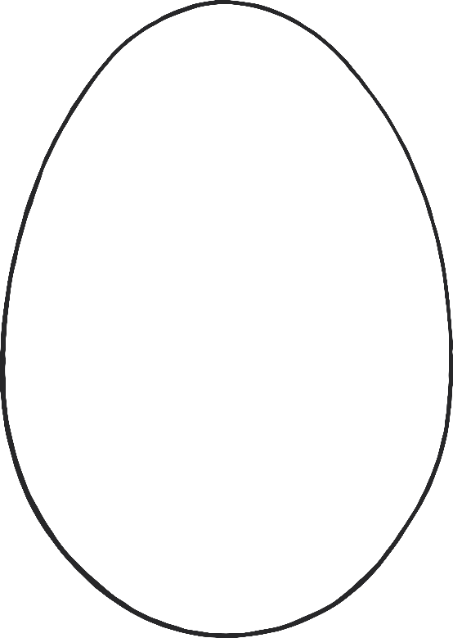

© 2022 Little Owls Resources

Colour Mixing

Mixture Colour

Second Colour

First Colour