Colour Match

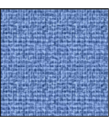

(Basic Memory/Colour recognition game)

* Cut and fold the picture cards (and preferably laminate)
* Place cards face down.
* Children to take turns turning over cards looking for one from their set.
* Winner is the first to collect a set.

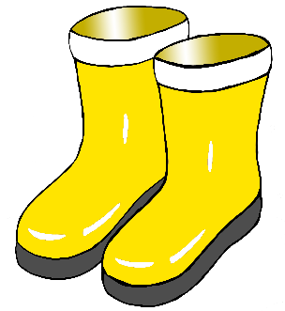

c

