Counters to be cut and laminated >>>

(For 1 or 2 players) Dice required

Clean Teeth Letters and Sounds Game

© 2021 Little Owls Resources

Roll the **dice**, move your toothbrush, and read the sound that you land on.

Help your clean the teeth!

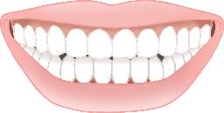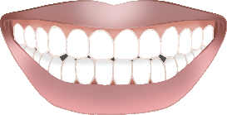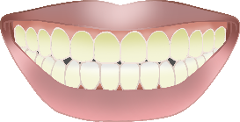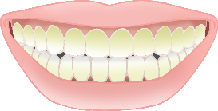

**Start**

m

s

f

l

b

ll

i

ck

g

a

t

c

e

k

o

h

u

d

r

ss

ff

p

m

© 2021 Little Owls Resources

n

**Start**

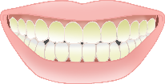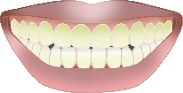

© 2021 Little Owls Resources

air

er

ng

zz

y

ear

igh

ai

oa

ar

z

ur

oi

**w**

th

ch

ee

sh

(long & short)

ure

oo

x

v

qu

o**w**

or

j