You will need: Some pairs of gloves for half of your group of children.

*(N.B. Print as many copies of the cards as you require.)*

* Two groups of children. One with gloves on and one with no gloves.
* Teach gloved children to clap once when they see the glove card.
* Teach the non-gloved children to clap once when they see the non-glove card.
* Talk with children about the difference in sounds created.
* Use the cards to help the children create interesting clapped rhythms.

Clapping Rhythms:

with & without gloves

© 2019 Little Owls Resources

© 2019 Little Owls Resources

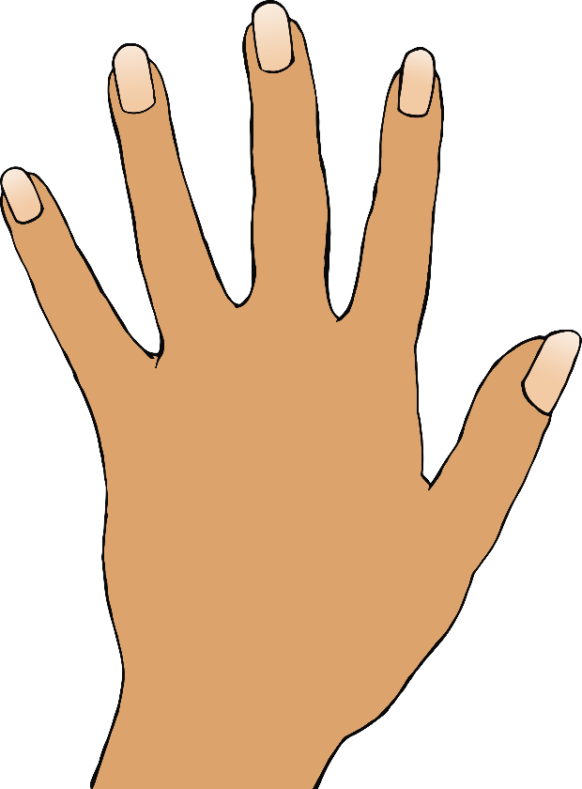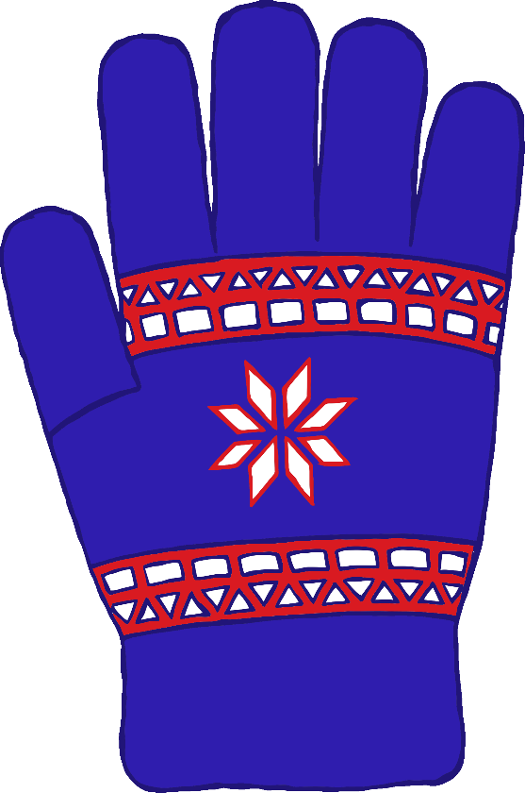

© 2019 Little Owls Resources

© 2019 Little Owls Resources



© 2019 Little Owls Resources

© 2019 Little Owls Resources

